**ENLACES**

**SISISISI**

[**https://vuetifyjs.com/en/components/buttons/#size**](https://vuetifyjs.com/en/components/buttons/#size)

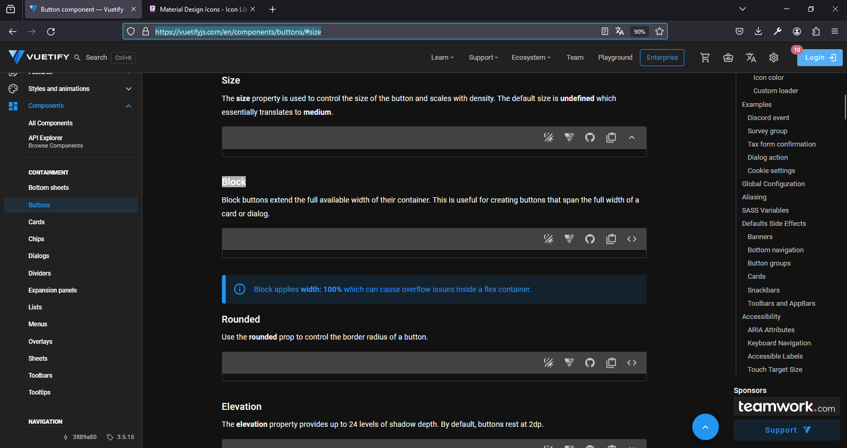

[**https://pictogrammers.com/library/mdi/**](https://pictogrammers.com/library/mdi/)

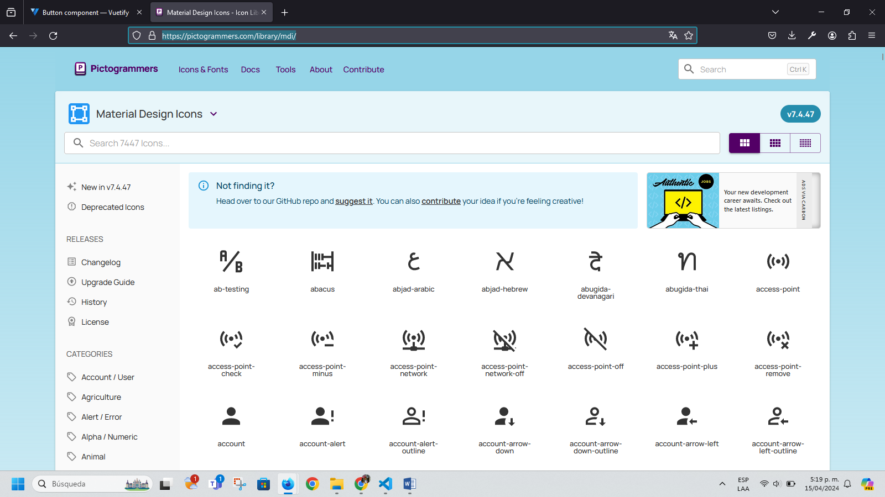

[**https://eslint.org/**](https://eslint.org/)

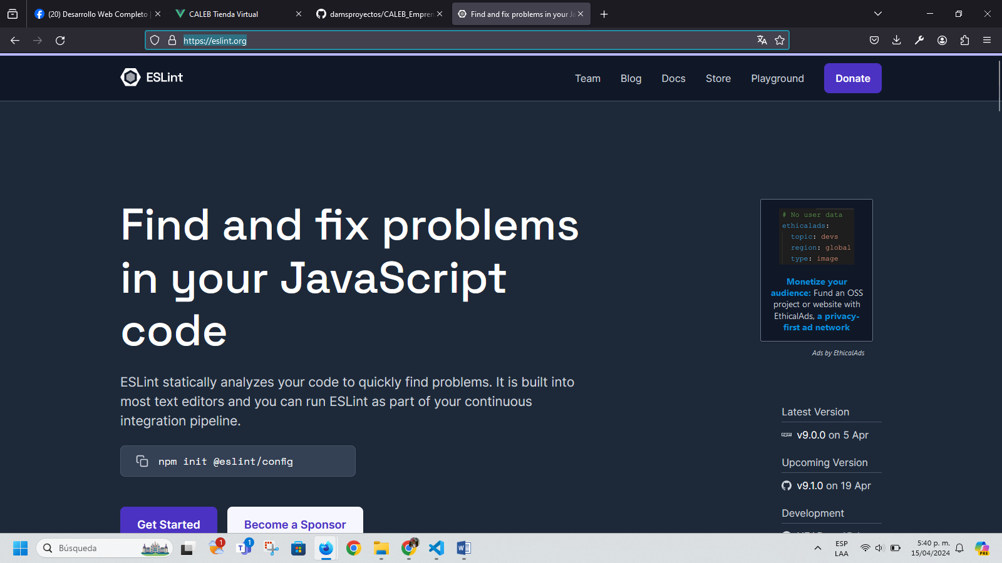

**PS C:\laragon\www\dams_proyectos> npm run lint**

**> dams_proyectos@0.0.0 lint**

**> eslint . --ext .vue,.js,.jsx,.cjs,.mjs,.ts,.tsx,.cts,.mts --fix --ignore-path .gitignore**

**C:\laragon\www\dams_proyectos\src\App2.vue**

**1:1 error Component name "App2" should always be multi-word vue/multi-word-component-names**

**C:\laragon\www\dams_proyectos\src\components\CategoryList.vue**

**8:18 error Parsing error: '}' expected**

**C:\laragon\www\dams_proyectos\src\components\ProductList.vue**

**12:25 error Parsing error: '}' expected**

**C:\laragon\www\dams_proyectos\src\components\TopBar.vue**

**3:10 warning 'RouterLink' is defined but never used @typescript-eslint/no-unused-vars**

**✖ 4 problems (3 errors, 1 warning)**

**PS C:\laragon\www\dams_proyectos>**

**PS C:\laragon\www\dams_proyectos> npm run lint**

**> dams_proyectos@0.0.0 lint**

**> eslint . --ext .vue,.js,.jsx,.cjs,.mjs,.ts,.tsx,.cts,.mts --fix --ignore-path .gitignore**

**C:\laragon\www\dams_proyectos\src\App2.vue**

**1:1 error Component name "App2" should always be multi-word vue/multi-word-component-names**

**✖ 1 problem (1 error, 0 warnings)**

**PS C:\laragon\www\dams_proyectos>**

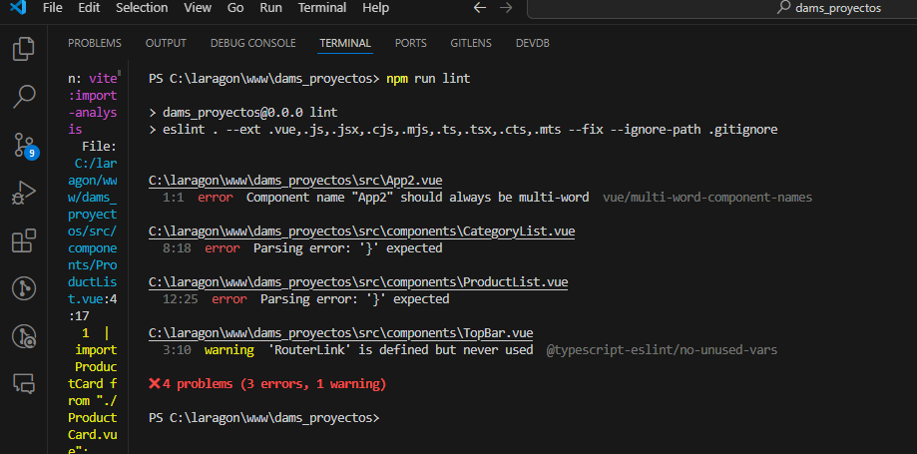

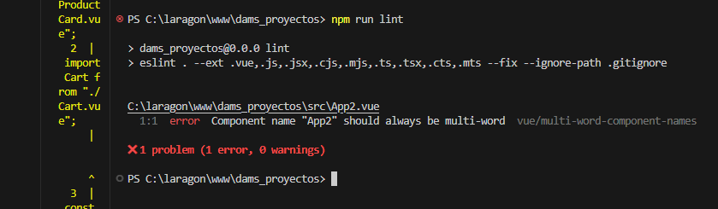

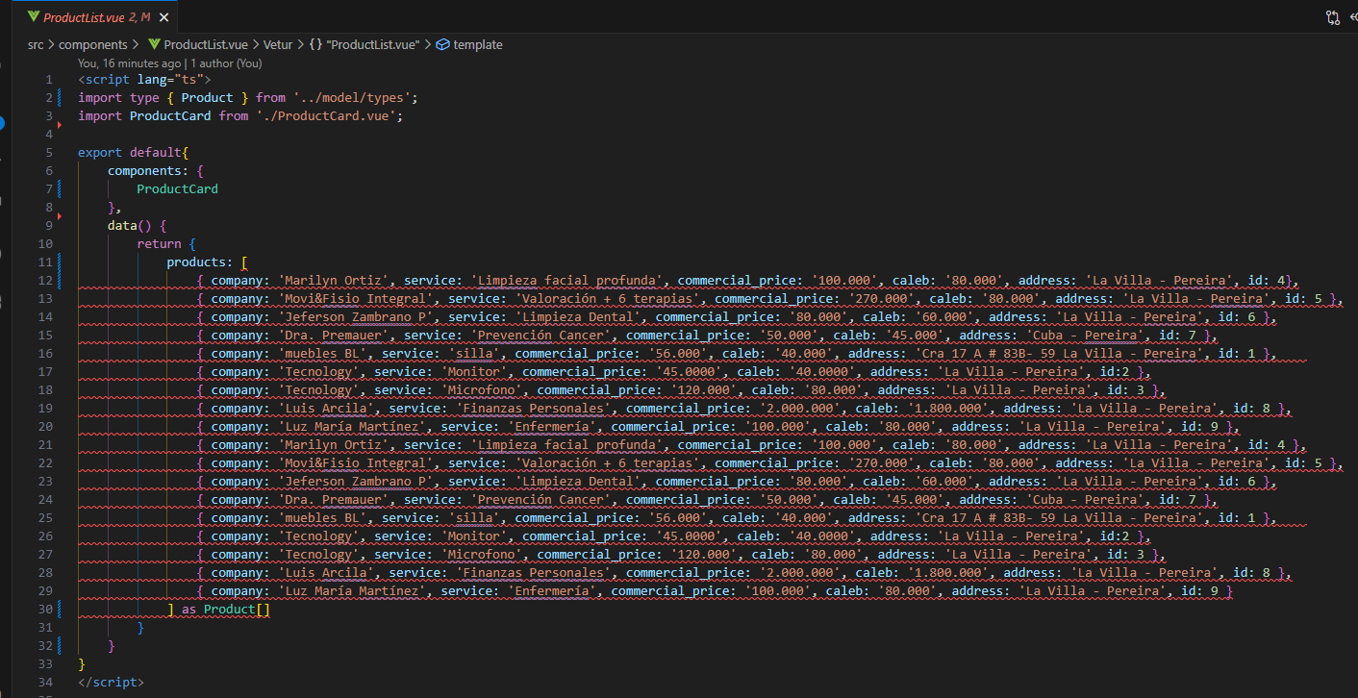

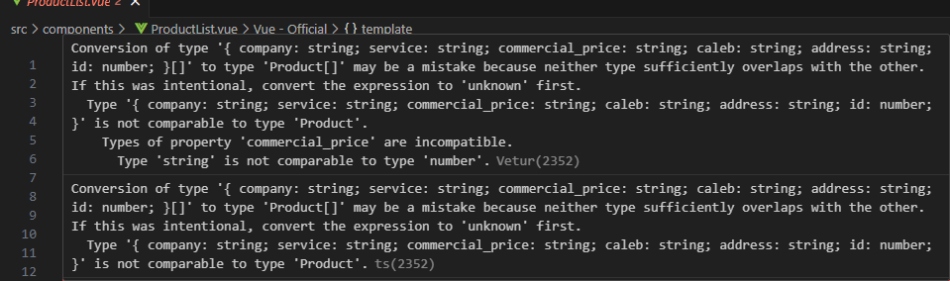

**Silla free copyrigth**

**Png.pngtree.com**

[**https://img.freepik.com/foto-gratis/mujer-visitando-cosmetologa-realizando-procedimientos-rejuvenecimiento_1303-26040.jpg?w=900&t=st=1713478321~exp=1713478921~hmac=4f54a059e9141747b58e4ad4e7960c71bf05379dbf87ae423fd3003af1784306**](https://img.freepik.com/foto-gratis/mujer-visitando-cosmetologa-realizando-procedimientos-rejuvenecimiento_1303-26040.jpg?w=900&t=st=1713478321~exp=1713478921~hmac=4f54a059e9141747b58e4ad4e7960c71bf05379dbf87ae423fd3003af1784306)

**fake random image**

[**https://www.freepik.es/search?format=search&query=fisioterapia%20fisica%20**](https://www.freepik.es/search?format=search&query=fisioterapia%20fisica%20)

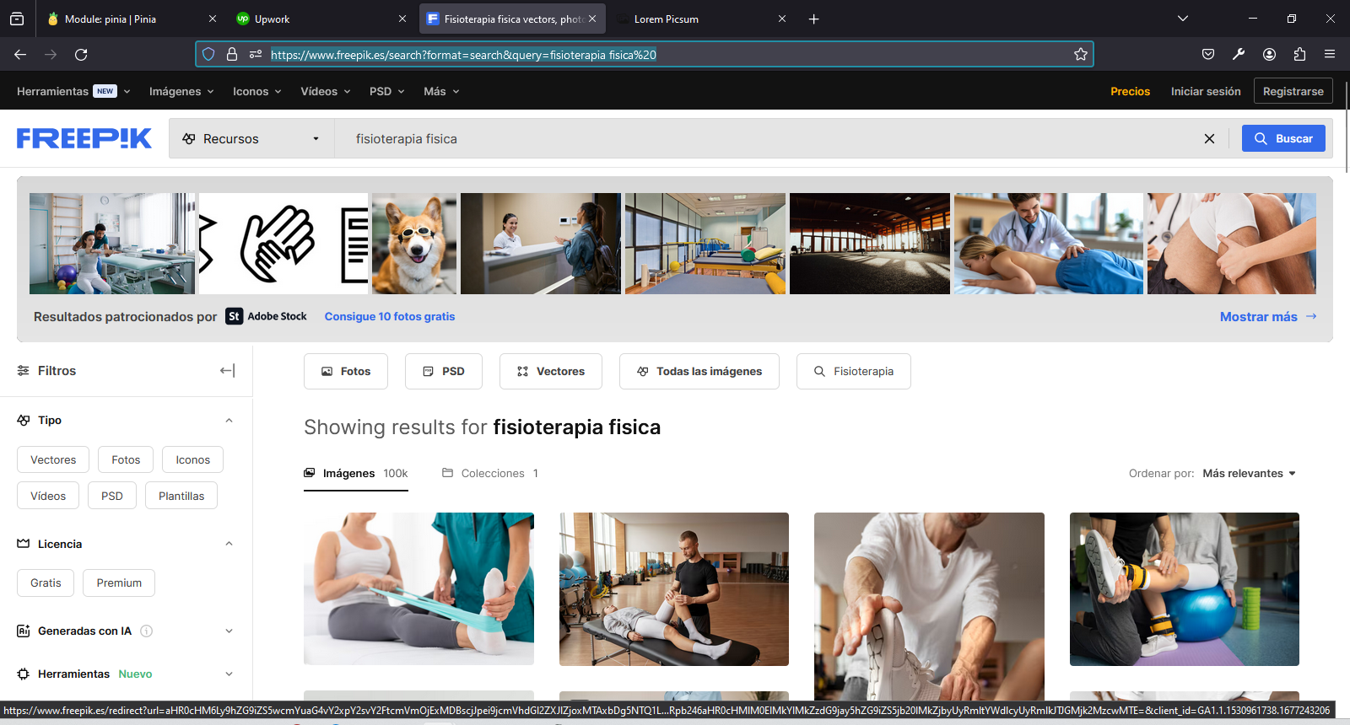

[**https://picsum.photos/**](https://picsum.photos/)

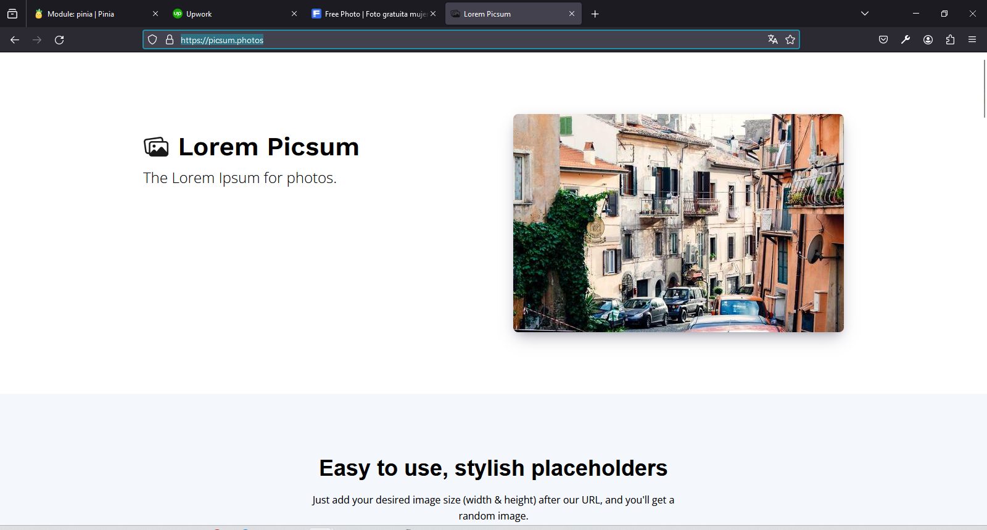

[**https://definicion.de/silla/**](https://definicion.de/silla/)

**Definición.de**

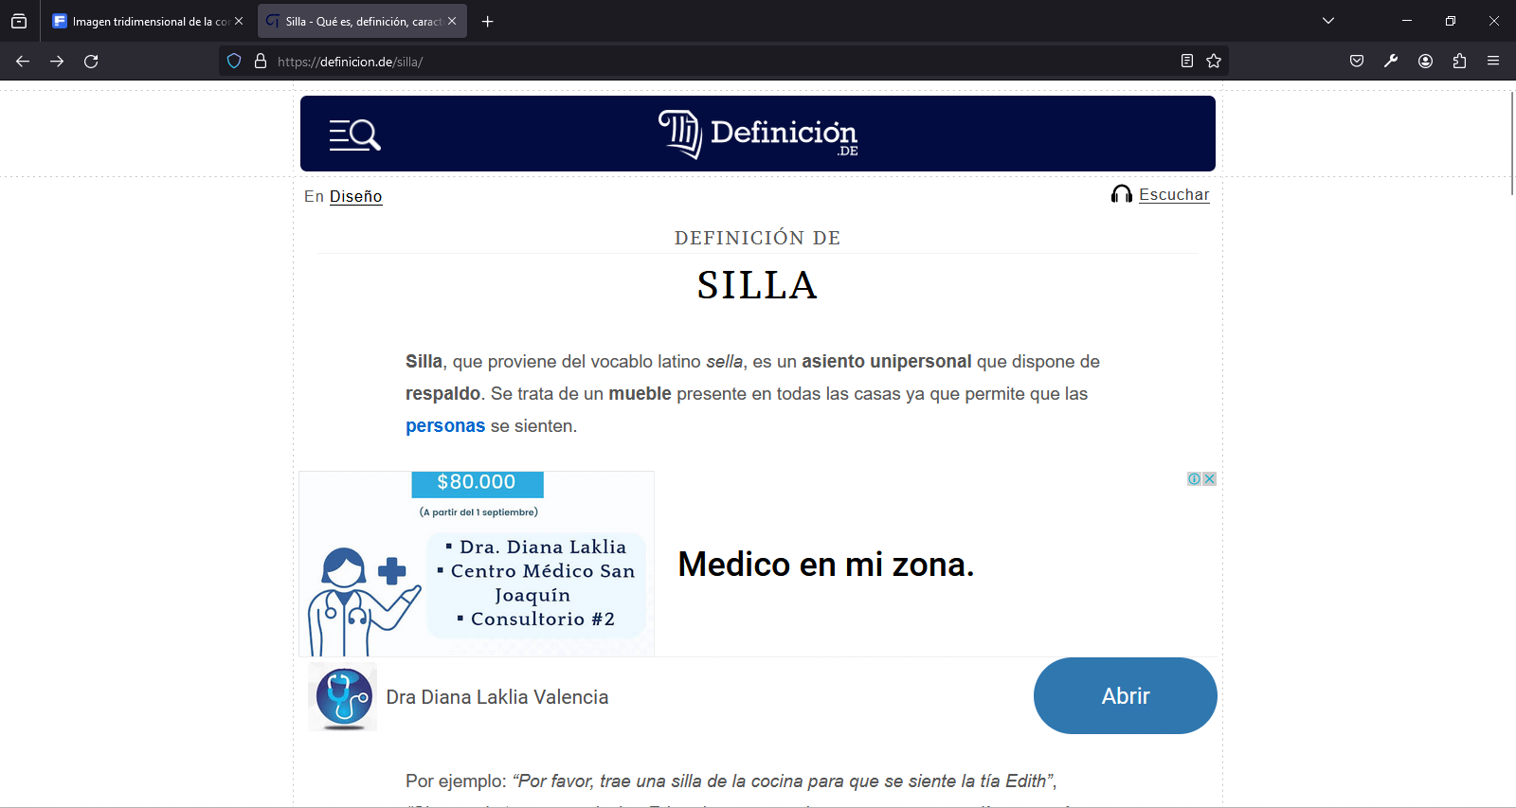

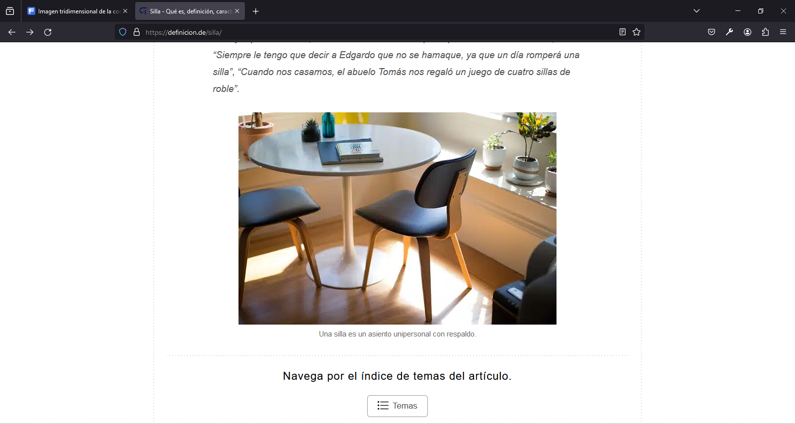

[**https://vuetifyjs.com/en/components/tables/**](https://vuetifyjs.com/en/components/tables/)

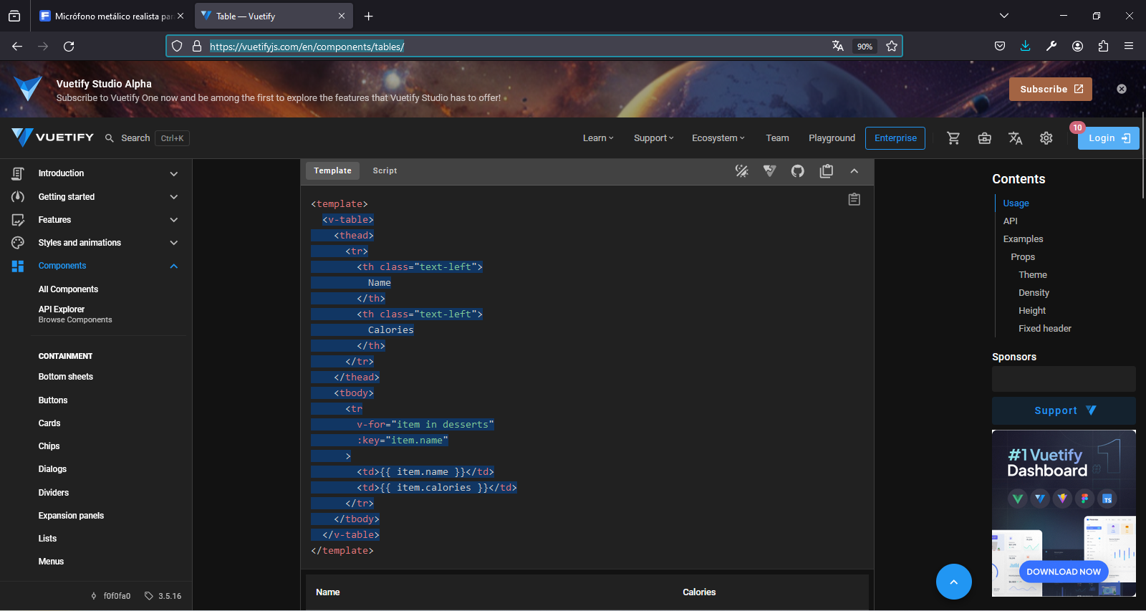

**PROBLEMA: No carga los productos en la página**

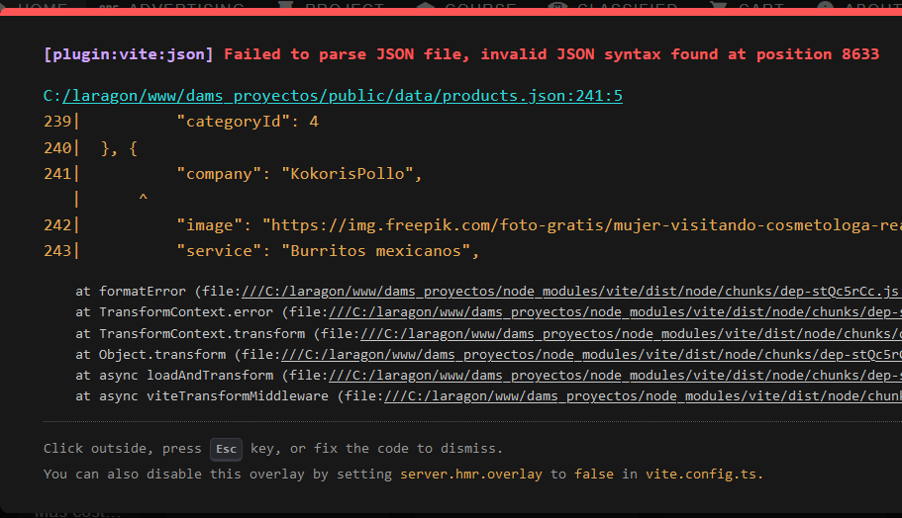

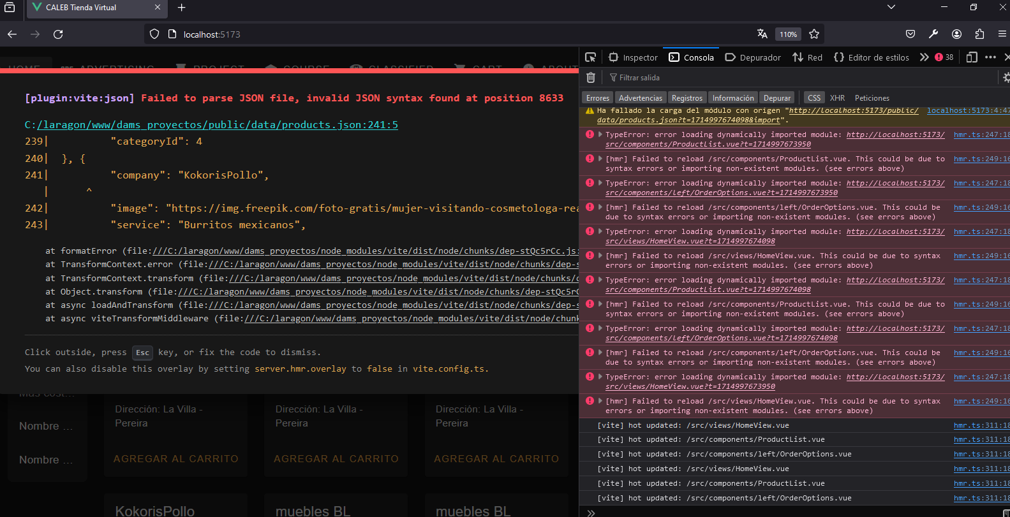

**SOLUCIÓN**

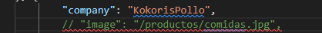

**En** archivos json no se puede comentar líneas; ya que crean errores de carga de páginas; debí borrar el comentario de image.

 "company": "KokorisPollo",

        // "image": "/productos/comidas.jpg",

        "service": "Pollo entero",

        "commercial_price": 30000,

        "caleb": "25000",

        "address": "La Villa - Pereira",

        "id": 27,

        "categoryId": 4

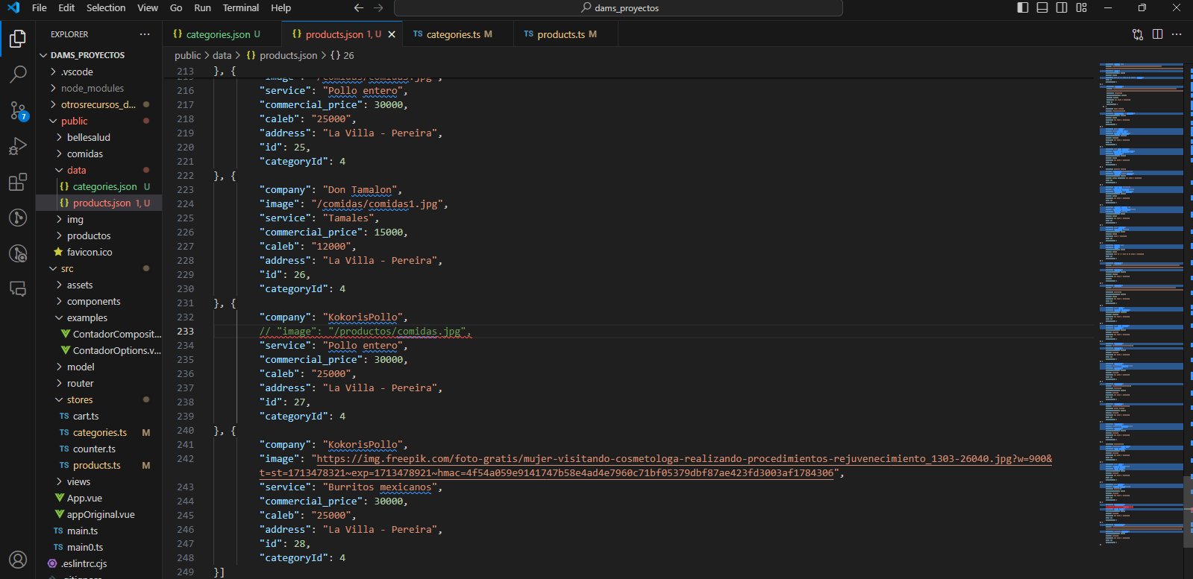

Al borrar el comentario de imagen me abrió correctamente la tienda

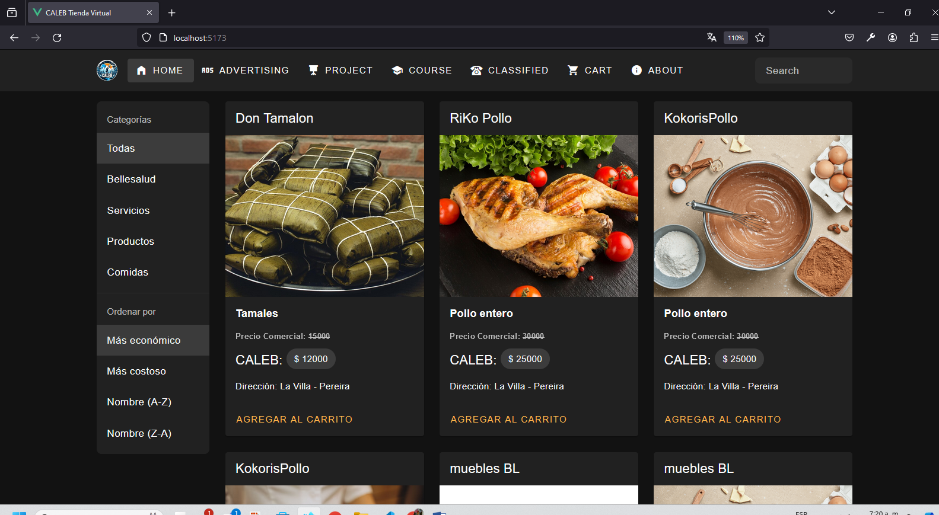

console.log(categoriesData): Agregamos un console.log para verificar cual es el contenido de categoriesData; para ver si realmente estamos leyendo bien los datos del archivo categories.json, osea que vemos los datos en la consola; eso significa que el import al store categories.ts es ÉXITOSO.

[**https://developer.mozilla.org/en-US/docs/Web/API**](https://developer.mozilla.org/en-US/docs/Web/API)

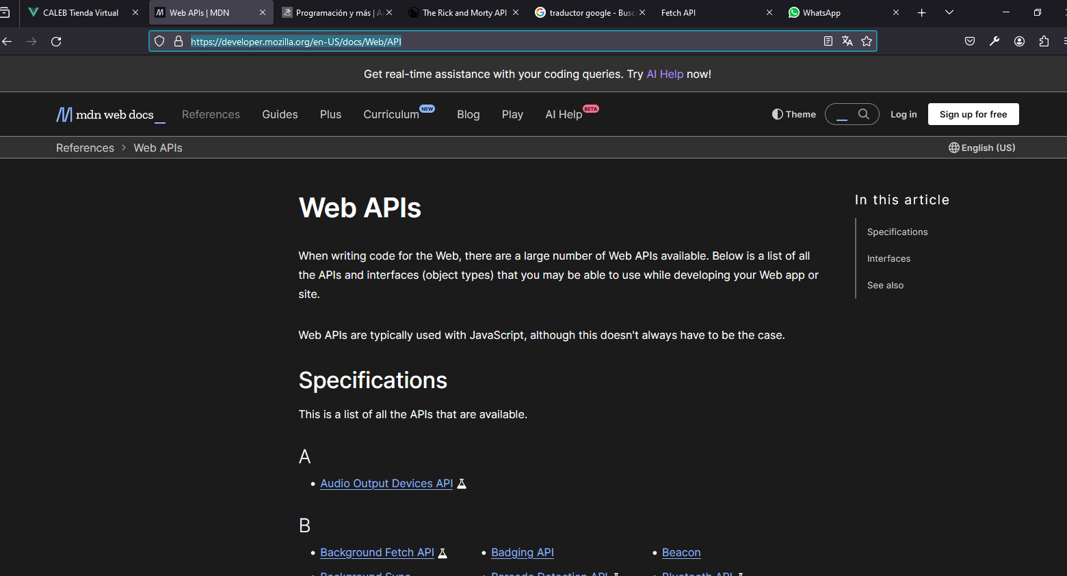

[**https://programacionymas.com/**](https://programacionymas.com/)



[**https://rickandmortyapi.com/**](https://rickandmortyapi.com/)



[**https://www.youtube.com/watch?v=DaGI20KYgS8**](https://www.youtube.com/watch?v=DaGI20KYgS8)

# Ajax, Fetch, Axios & jQuery ⚡ 5 minutos 🎉 Desde cero

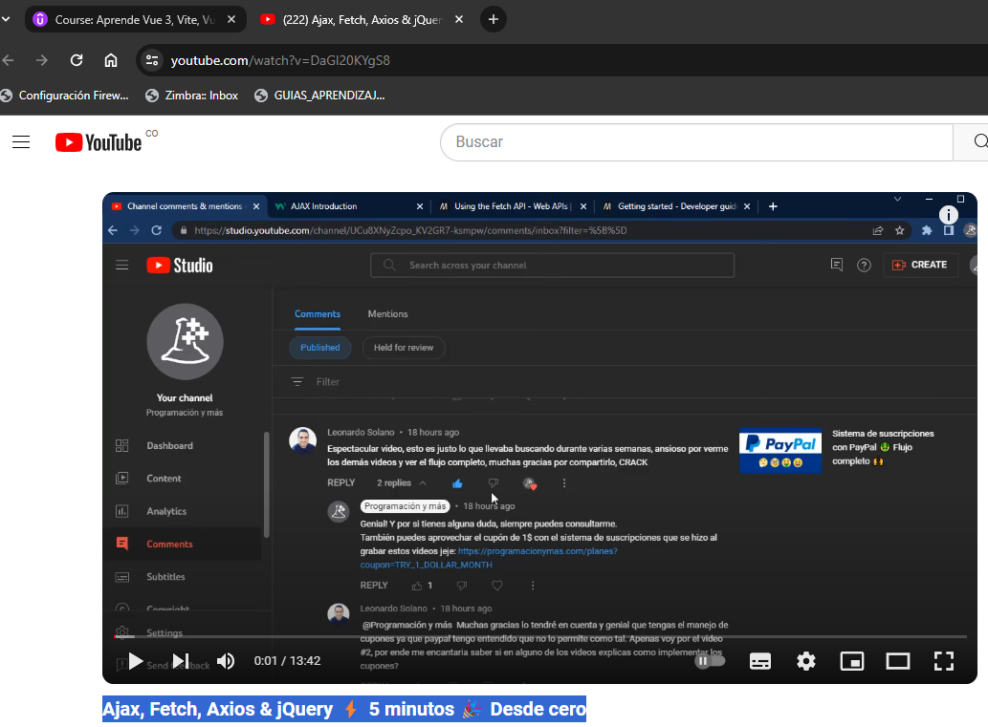

[**https://vuetifyjs.com/en/components/progress-linear/#buffering**](https://vuetifyjs.com/en/components/progress-linear/#buffering)

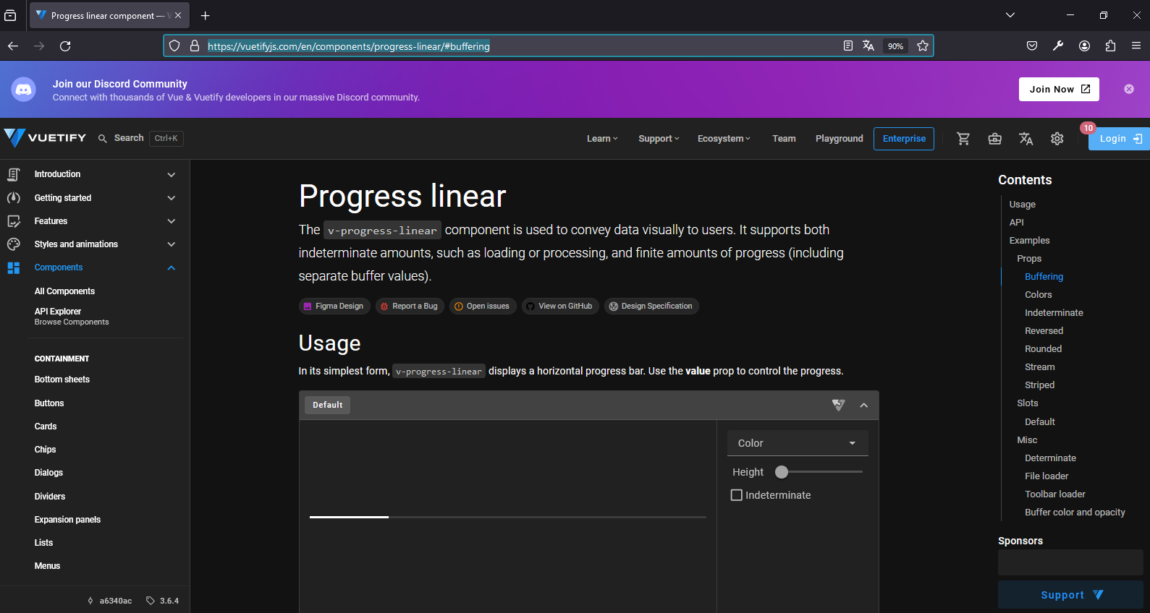

**REPOSISTORIO GIT HUB**

<https://github.com/damsproyectos/CALEB_Emprendimiento_Liderazgo>

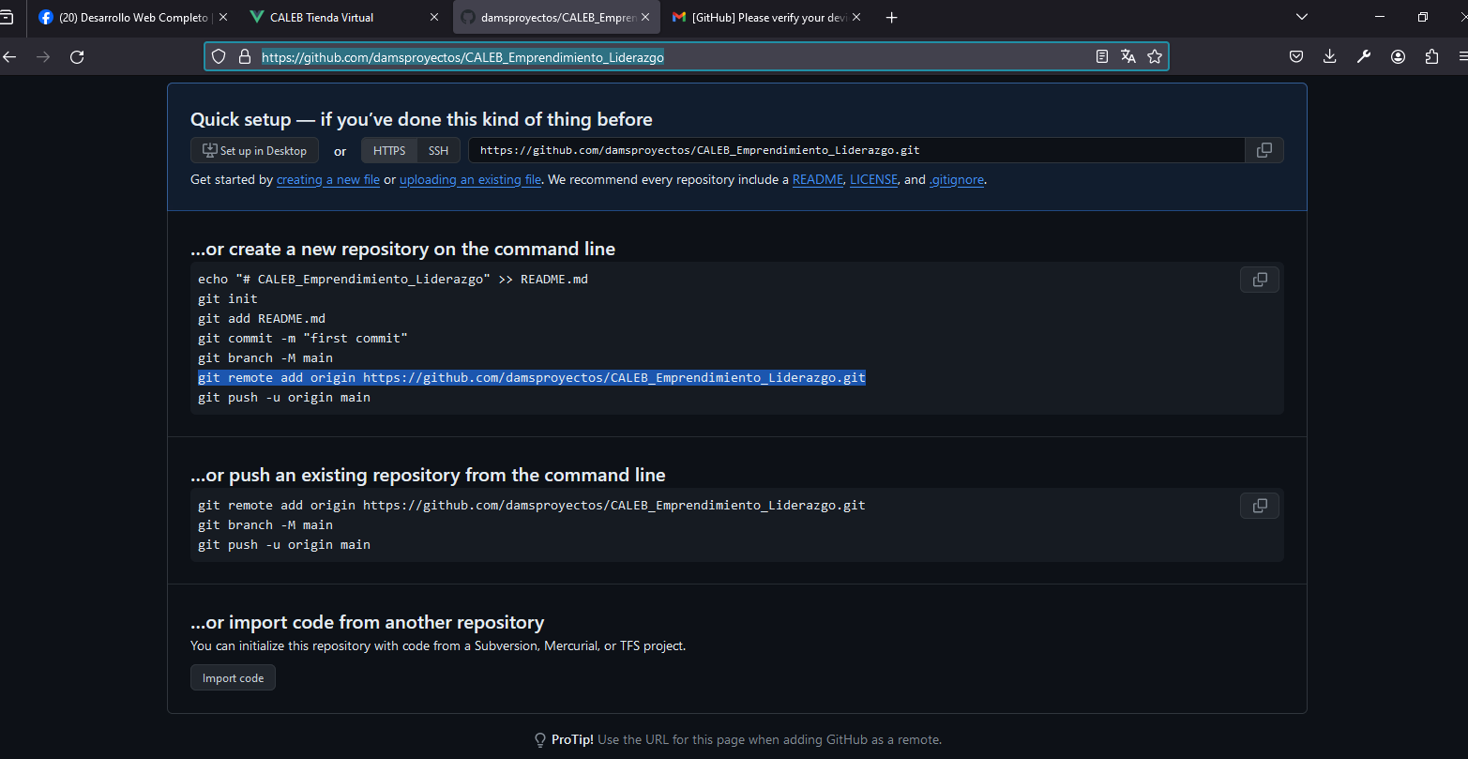

PS C:\laragon\www\dams_proyectos> git

usage: git [-v | --version] [-h | --help] [-C <path>] [-c <name>=<value>]

[--exec-path[=<path>]] [--html-path] [--man-path] [--info-path]

[-p | --paginate | -P | --no-pager] [--no-replace-objects] [--bare]

[--git-dir=<path>] [--work-tree=<path>] [--namespace=<name>]

[--super-prefix=<path>] [--config-env=<name>=<envvar>]

<command> [<args>]

These are common Git commands used in various situations:

start a working area (see also: git help tutorial)

clone Clone a repository into a new directory

init Create an empty Git repository or reinitialize an existing one

work on the current change (see also: git help everyday)

add Add file contents to the index

mv Move or rename a file, a directory, or a symlink

restore Restore working tree files

rm Remove files from the working tree and from the index

examine the history and state (see also: git help revisions)

bisect Use binary search to find the commit that introduced a bug

diff Show changes between commits, commit and working tree, etc

grep Print lines matching a pattern

log Show commit logs

show Show various types of objects

status Show the working tree status

grow, mark and tweak your common history

branch List, create, or delete branches

commit Record changes to the repository

merge Join two or more development histories together

rebase Reapply commits on top of another base tip

reset Reset current HEAD to the specified state

switch Switch branches

tag Create, list, delete or verify a tag object signed with GPG

collaborate (see also: git help workflows)

fetch Download objects and refs from another repository

pull Fetch from and integrate with another repository or a local branch

push Update remote refs along with associated objects

'git help -a' and 'git help -g' list available subcommands and some

concept guides. See 'git help <command>' or 'git help <concept>'

to read about a specific subcommand or concept.

See 'git help git' for an overview of the system.

PS C:\laragon\www\dams_proyectos> git init

Initialized empty Git repository in C:/laragon/www/dams_proyectos/.git/

PS C:\laragon\www\dams_proyectos> git add .

warning: in the working copy of '.eslintrc.cjs', LF will be replaced by CRLF the next time Git touches it

warning: in the working copy of '.gitignore', LF will be replaced by CRLF the next time Git touches it

warning: in the working copy of '.vscode/extensions.json', LF will be replaced by CRLF the next time Git touches it

warning: in the working copy of 'README.md', LF will be replaced by CRLF the next time Git touches it

warning: in the working copy of 'env.d.ts', LF will be replaced by CRLF the next time Git touches it

warning: in the working copy of 'index.html', LF will be replaced by CRLF the next time Git touches it

warning: in the working copy of 'package-lock.json', LF will be replaced by CRLF the next time Git touches it

warning: in the working copy of 'package.json', LF will be replaced by CRLF the next time Git touches it

warning: in the working copy of 'src/App.vue', LF will be replaced by CRLF the next time Git touches it

warning: in the working copy of 'src/App2.vue', LF will be replaced by CRLF the next time Git touches it

warning: in the working copy of 'src/assets/base.css', LF will be replaced by CRLF the next time Git touches it

warning: in the working copy of 'src/assets/logo.svg', LF will be replaced by CRLF the next time Git touches it

warning: in the working copy of 'src/assets/main.css', LF will be replaced by CRLF the next time Git touches it

warning: in the working copy of 'src/components/HelloWorld.vue', LF will be replaced by CRLF the next time Git touches it

warning: in the working copy of 'src/components/TheWelcome.vue', LF will be replaced by CRLF the next time Git touches it

warning: in the working copy of 'src/components/WelcomeItem.vue', LF will be replaced by CRLF the next time Git touches it

warning: in the working copy of 'src/components/icons/IconCommunity.vue', LF will be replaced by CRLF the next time Git touches it

warning: in the working copy of 'src/components/icons/IconDocumentation.vue', LF will be replaced by CRLF the next time Git touches it

warning: in the working copy of 'src/components/icons/IconEcosystem.vue', LF will be replaced by CRLF the next time Git touches it

warning: in the working copy of 'src/components/icons/IconSupport.vue', LF will be replaced by CRLF the next time Git touches it

warning: in the working copy of 'src/components/icons/IconTooling.vue', LF will be replaced by CRLF the next time Git touches it

warning: in the working copy of 'src/main.ts', LF will be replaced by CRLF the next time Git touches it

warning: in the working copy of 'src/router/index.ts', LF will be replaced by CRLF the next time Git touches it

warning: in the working copy of 'src/stores/cart.ts', LF will be replaced by CRLF the next time Git touches it

warning: in the working copy of 'src/stores/counter.ts', LF will be replaced by CRLF the next time Git touches it

warning: in the working copy of 'src/views/AboutView.vue', LF will be replaced by CRLF the next time Git touches it

warning: in the working copy of 'src/views/HomeView.vue', LF will be replaced by CRLF the next time Git touches it

warning: in the working copy of 'tsconfig.app.json', LF will be replaced by CRLF the next time Git touches it

warning: in the working copy of 'tsconfig.json', LF will be replaced by CRLF the next time Git touches it

warning: in the working copy of 'tsconfig.node.json', LF will be replaced by CRLF the next time Git touches it

warning: in the working copy of 'vite.config.ts', LF will be replaced by CRLF the next time Git touches it

PS C:\laragon\www\dams_proyectos> git commit -m "Base Project"

[master (root-commit) 14a154d] Base Project

46 files changed, 8319 insertions(+)

create mode 100644 .eslintrc.cjs

create mode 100644 .gitignore

create mode 100644 .vscode/extensions.json

create mode 100644 README.md

create mode 100644 env.d.ts

create mode 100644 index.html

create mode 100644 package-lock.json

create mode 100644 package.json

create mode 100644 public/favicon.ico

create mode 100644 src/App.vue

create mode 100644 src/App2.vue

create mode 100644 src/assets/base.css

create mode 100644 src/assets/logo.svg

create mode 100644 src/assets/main.css

create mode 100644 src/components/Cart.vue

create mode 100644 src/components/CategoryList.vue

create mode 100644 src/components/HelloWorld.vue

create mode 100644 src/components/ProductCard.vue

create mode 100644 src/components/ProductList.vue

create mode 100644 src/components/TheWelcome.vue

create mode 100644 src/components/TopBar.vue

create mode 100644 src/components/WelcomeItem.vue

create mode 100644 src/components/icons/IconCommunity.vue

create mode 100644 src/components/icons/IconDocumentation.vue

create mode 100644 src/components/icons/IconEcosystem.vue

create mode 100644 src/components/icons/IconSupport.vue

create mode 100644 src/components/icons/IconTooling.vue

create mode 100644 src/examples/ContadorComposition.vue

create mode 100644 src/examples/ContadorOptions.vue

create mode 100644 src/main.ts

create mode 100644 src/main0.ts

create mode 100644 src/model/types.ts

create mode 100644 src/router/index.ts

create mode 100644 src/stores/cart.ts

create mode 100644 src/stores/counter.ts

create mode 100644 src/views/AboutView.vue

create mode 100644 src/views/AdvertisingView.vue

create mode 100644 src/views/CartView.vue

create mode 100644 src/views/ClassifiedView.vue

create mode 100644 src/views/CourseView.vue

create mode 100644 src/views/HomeView.vue

create mode 100644 src/views/ProjectView.vue

create mode 100644 tsconfig.app.json

create mode 100644 tsconfig.json

create mode 100644 tsconfig.node.json

create mode 100644 vite.config.ts

PS C:\laragon\www\dams_proyectos> git remote add origin https://github.com/damsproyectos/CALEB_Emprendimiento_Liderazgo.git

PS C:\laragon\www\dams_proyectos> git push -u origin master

Enumerating objects: 58, done.

Counting objects: 100% (58/58), done.

Delta compression using up to 4 threads

Compressing objects: 100% (53/53), done.

Writing objects: 100% (58/58), 83.20 KiB | 781.00 KiB/s, done.

Total 58 (delta 2), reused 0 (delta 0), pack-reused 0

remote: Resolving deltas: 100% (2/2), done.

To https://github.com/damsproyectos/CALEB_Emprendimiento_Liderazgo.git

* [new branch] master -> master

branch 'master' set up to track 'origin/master'.

PS C:\laragon\www\dams_proyectos>

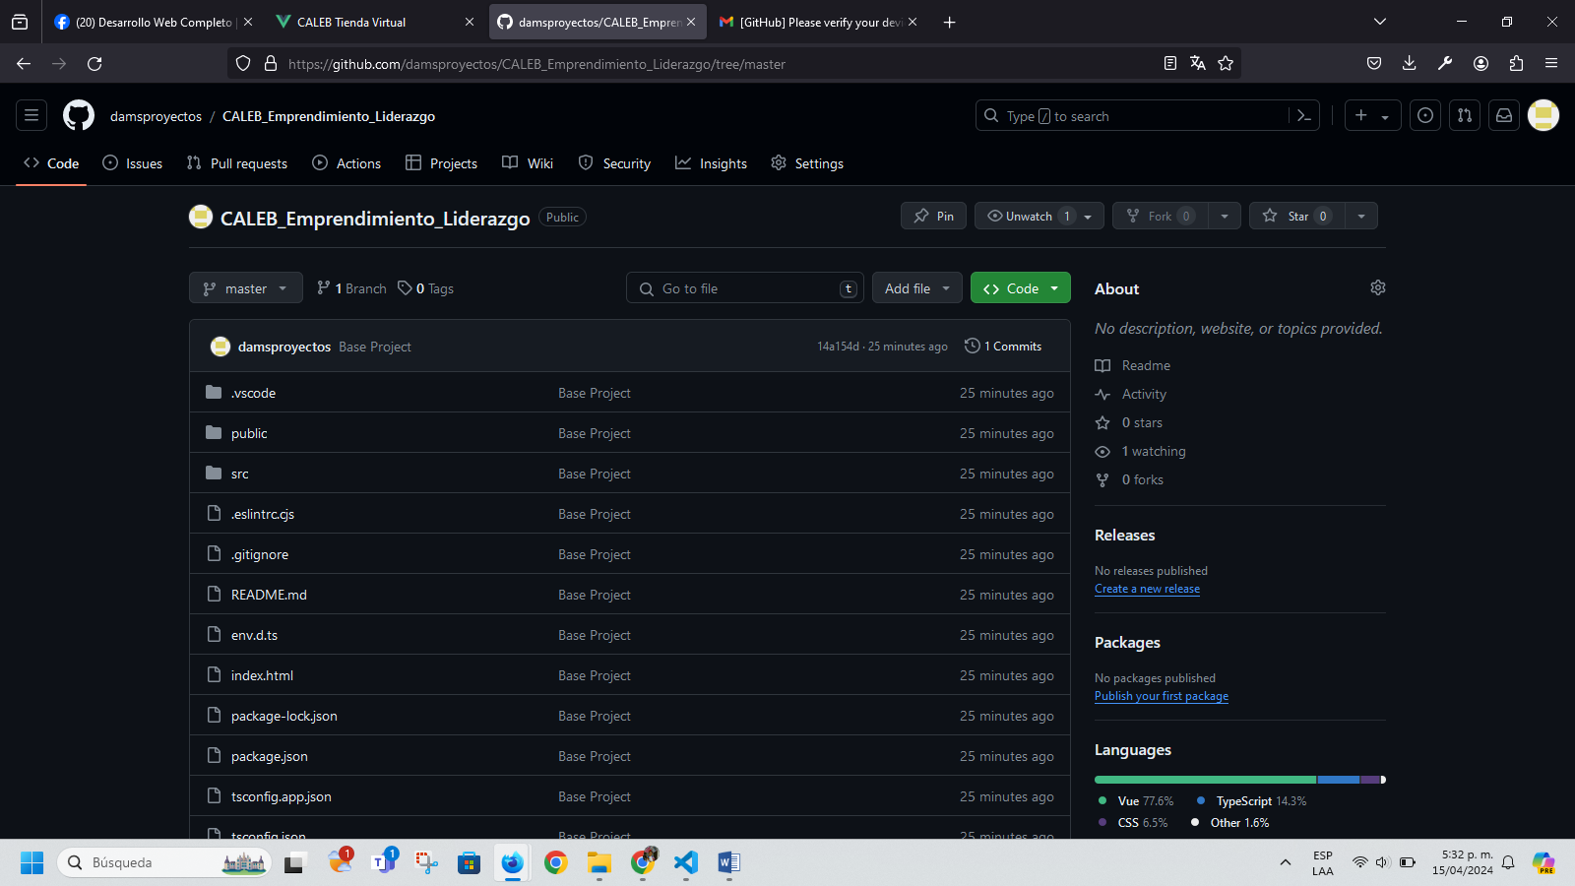

PS C:\laragon\www\dams_proyectos> git status

On branch master

Your branch is up to date with 'origin/master'.

Changes not staged for commit:

(use "git add/rm <file>..." to update what will be committed)

(use "git restore <file>..." to discard changes in working directory)

modified: src/App.vue

deleted: src/components/Cart.vue

modified: src/components/CategoryList.vue

modified: src/components/ProductList.vue

modified: src/components/TopBar.vue

modified: src/views/CartView.vue

Untracked files:

(use "git add <file>..." to include in what will be committed)

otrosrecursos_damsproyectos/

src/components/ShoppingCart.vue

no changes added to commit (use "git add" and/or "git commit -a")

PS C:\laragon\www\dams_proyectos> git add .

warning: in the working copy of 'src/App.vue', LF will be replaced by CRLF the next time Git touches it

PS C:\laragon\www\dams_proyectos> git commit -m "Fix Lint Warnings"

[master dfb6686] Fix Lint Warnings

8 files changed, 21 insertions(+), 28 deletions(-)

create mode 100644 otrosrecursos_damsproyectos/otrosrecursos_damsproyectos.docx

create mode 100644 otrosrecursos_damsproyectos/~$rosrecursos_damsproyectos.docx

rename src/components/{Cart.vue => ShoppingCart.vue} (93%)

PS C:\laragon\www\dams_proyectos> git push origin master

Enumerating objects: 23, done.

Counting objects: 100% (23/23), done.

Delta compression using up to 4 threads

Compressing objects: 100% (14/14), done.

Writing objects: 100% (14/14), 7.64 MiB | 676.00 KiB/s, done.

Total 14 (delta 8), reused 0 (delta 0), pack-reused 0

remote: Resolving deltas: 100% (8/8), completed with 8 local objects.

To https://github.com/damsproyectos/CALEB_Emprendimiento_Liderazgo.git

14a154d..dfb6686 master -> master

PS C:\laragon\www\dams_proyectos>

<https://github.com/damsproyectos/CALEB_Emprendimiento_Liderazgo>

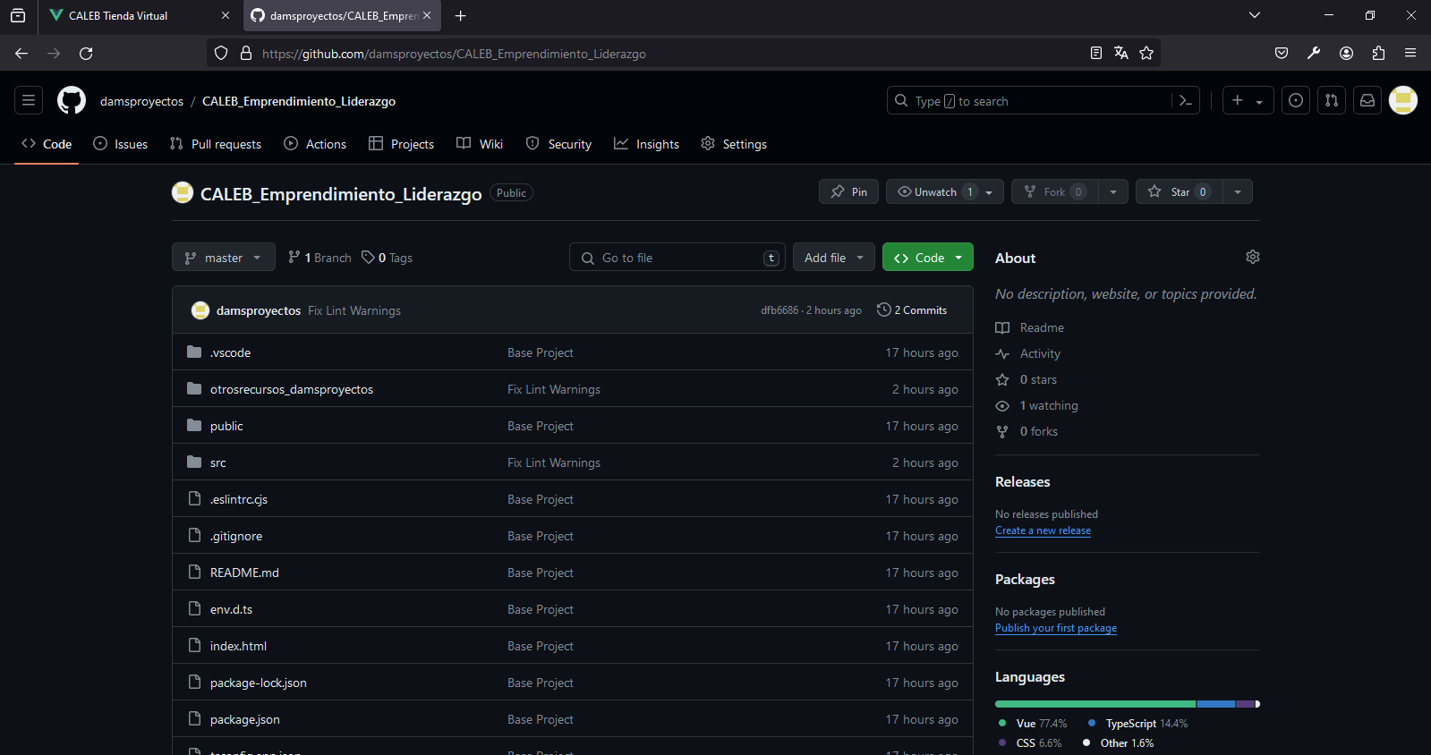

PS C:\laragon\www\dams_proyectos> git status

On branch master

Your branch is up to date with 'origin/master'.

Changes not staged for commit:

(use "git add <file>..." to update what will be committed)

(use "git restore <file>..." to discard changes in working directory)

modified: src/components/CategoryList.vue

modified: src/components/ProductCard.vue

modified: src/components/ProductList.vue

modified: src/model/types.ts

Untracked files:

(use "git add <file>..." to include in what will be committed)

public/bellesalud/

public/productos/

no changes added to commit (use "git add" and/or "git commit -a")

PS C:\laragon\www\dams_proyectos> git add .

PS C:\laragon\www\dams_proyectos> git commit -m "Add images for products, Add categoryId"

[master e7c5adf] Add images for products, Add categoryId

14 files changed, 261 insertions(+), 33 deletions(-)

create mode 100644 public/bellesalud/enfermeria.webp

create mode 100644 public/bellesalud/marilyn.jpeg

create mode 100644 public/bellesalud/movifisio.jpeg

create mode 100644 public/bellesalud/odontologia.jpeg

create mode 100644 public/productos/headphones.jpg

create mode 100644 public/productos/microfono.jpg

create mode 100644 public/productos/monitor.jpg

create mode 100644 public/productos/mouse.jpg

create mode 100644 public/productos/parlantes.jpg

create mode 100644 public/productos/silla.webp

PS C:\laragon\www\dams_proyectos> git push origin master

Enumerating objects: 31, done.

Counting objects: 100% (31/31), done.

Delta compression using up to 4 threads

Compressing objects: 100% (21/21), done.

Writing objects: 100% (22/22), 3.60 MiB | 608.00 KiB/s, done.

Total 22 (delta 6), reused 0 (delta 0), pack-reused 0

remote: Resolving deltas: 100% (6/6), completed with 6 local objects.

To https://github.com/damsproyectos/CALEB_Emprendimiento_Liderazgo.git

d95e701..e7c5adf master -> master

PS C:\laragon\www\dams_proyectos>

**Problema:**

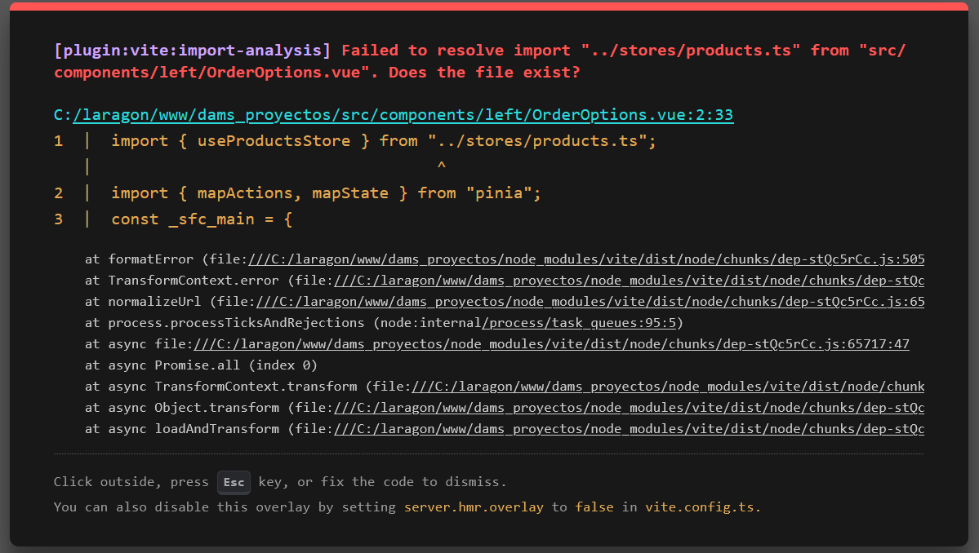

Solución:

CategoryList

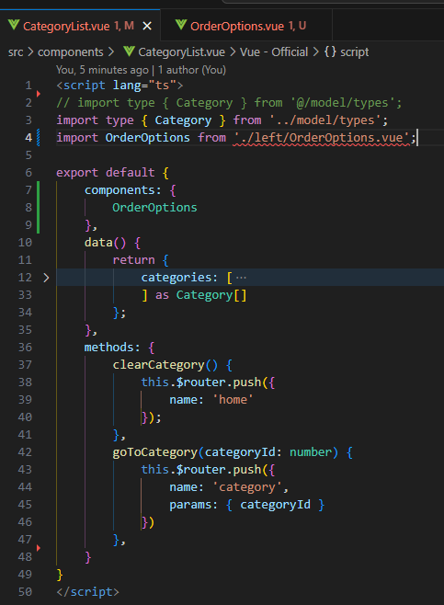

OrderOptions.vue

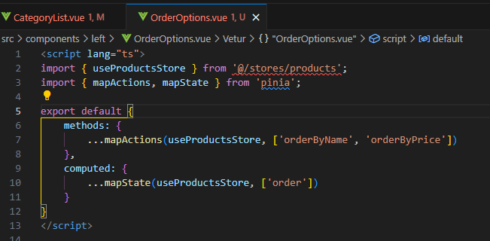

Problema:

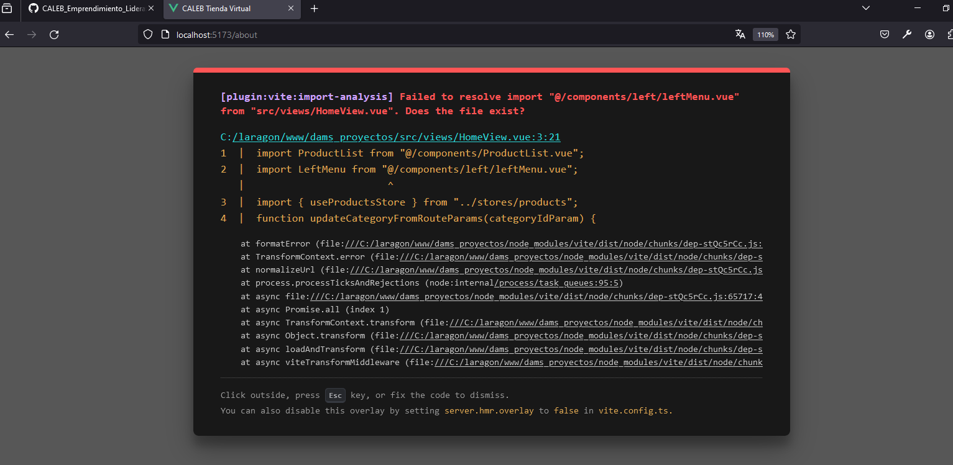

Solución: Se cambió la letra (l) minúscula por la letra (L) Mayuscula en /LeftMenu.vue y dejó de presentar el error; y volvió a funcionar el aplicativo Caleb Tienda Virtual

import LeftMenu from '@/components/left/LeftMenu.vue';

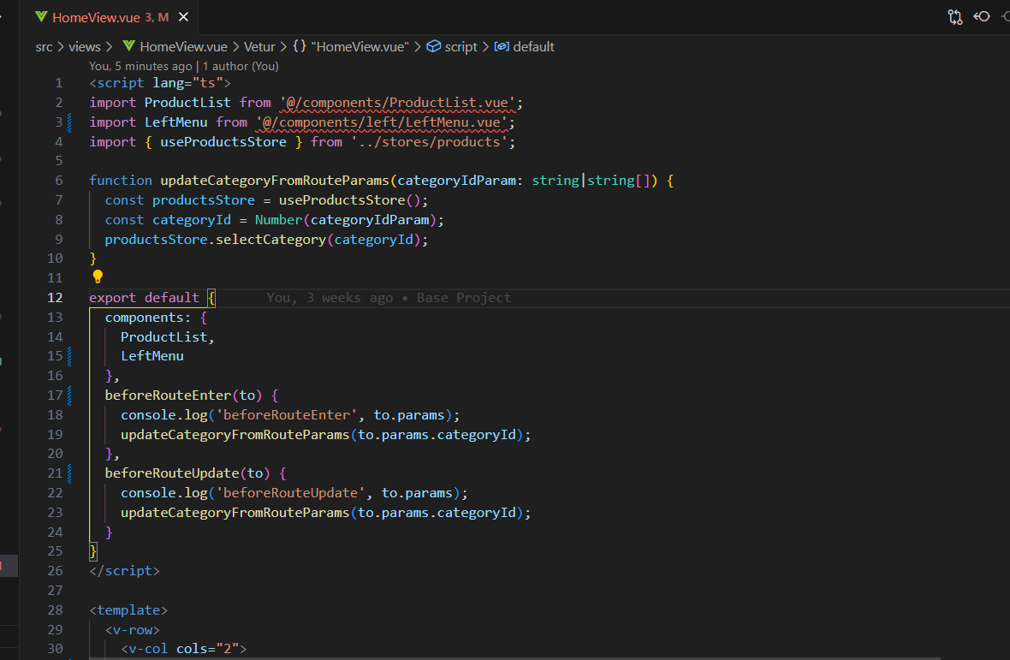

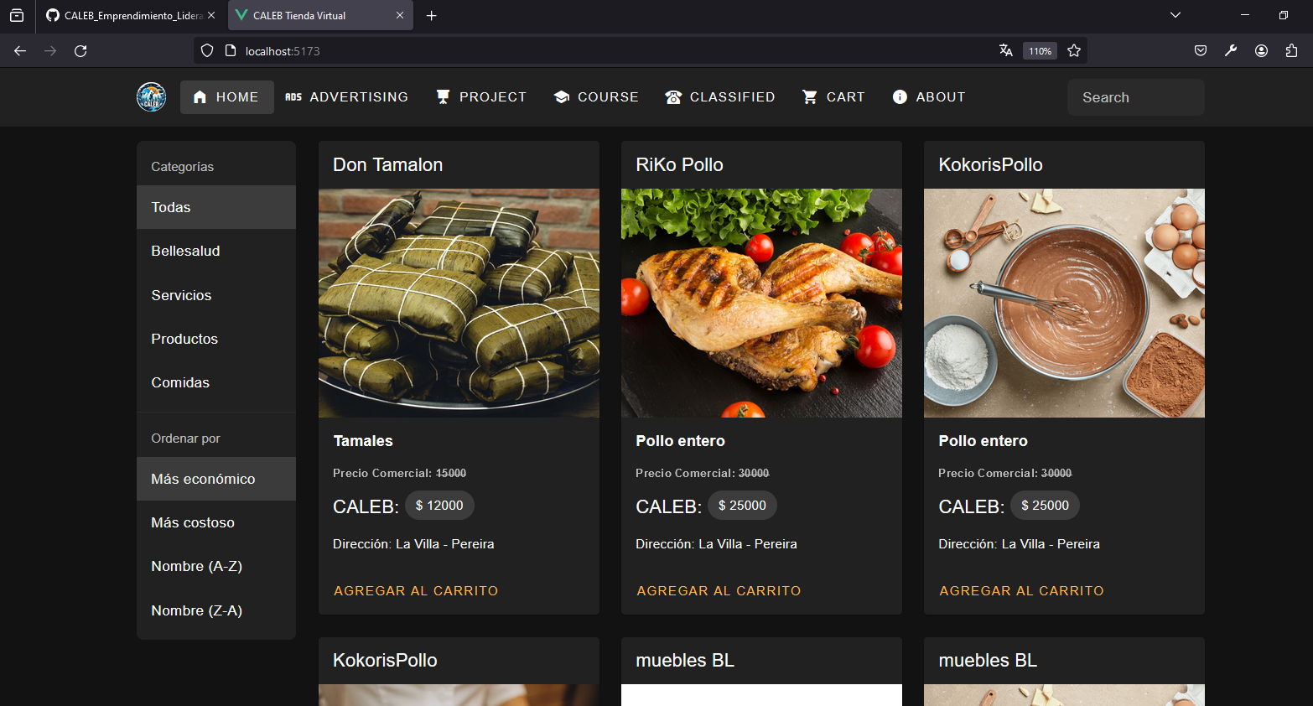

**GIT HUB**

PS C:\laragon\www\dams_proyectos> git status

On branch master

Your branch is up to date with 'origin/master'.

Changes not staged for commit:

(use "git add <file>..." to update what will be committed)

(use "git restore <file>..." to discard changes in working directory)

modified: otrosrecursos_damsproyectos/otrosrecursos_damsproyectos.docx

modified: src/components/CategoryList.vue

Untracked files:

(use "git add <file>..." to include in what will be committed)

otrosrecursos_damsproyectos/~$rosrecursos_damsproyectos.docx

otrosrecursos_damsproyectos/~WRL0892.tmp

src/components/left/

no changes added to commit (use "git add" and/or "git commit -a")

PS C:\laragon\www\dams_proyectos> git add .

PS C:\laragon\www\dams_proyectos> git commit -m "video 101 Vlist Active Order Item"

[master 2b9a308] video 101 Vlist Active Order Item

5 files changed, 37 insertions(+), 17 deletions(-)

create mode 100644 otrosrecursos_damsproyectos/~$rosrecursos_damsproyectos.docx

create mode 100644 otrosrecursos_damsproyectos/~WRL0892.tmp

create mode 100644 src/components/left/OrderOptions.vue

PS C:\laragon\www\dams_proyectos> git push origin master

Enumerating objects: 16, done.

Counting objects: 100% (16/16), done.

Delta compression using up to 4 threads

Compressing objects: 100% (9/9), done.

Writing objects: 100% (10/10), 181.31 KiB | 748.00 KiB/s, done.

Total 10 (delta 6), reused 0 (delta 0), pack-reused 0

remote: Resolving deltas: 100% (6/6), completed with 5 local objects.

To https://github.com/damsproyectos/CALEB_Emprendimiento_Liderazgo.git

1885cc4..2b9a308 master -> master

PS C:\laragon\www\dams_proyectos>

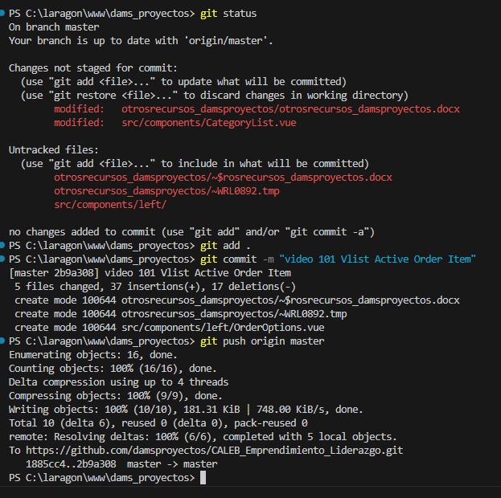

**npm run lint**

PS C:\laragon\www\dams_proyectos> **npm run lint**

> dams_proyectos@0.0.0 lint

> eslint . --ext .vue,.js,.jsx,.cjs,.mjs,.ts,.tsx,.cts,.mts --fix --ignore-path .gitignore

C:\laragon\www\dams_proyectos\src\App2.vue

1:1 error Component name "App2" should always be multi-word vue/multi-word-component-names

C:\laragon\www\dams_proyectos\src\views\HomeView.vue

17:24 warning 'from' is defined but never used @typescript-eslint/no-unused-vars

21:25 warning 'from' is defined but never used @typescript-eslint/no-unused-vars

✖ 3 problems (1 error, 2 warnings)

PS C:\laragon\www\dams_proyectos>

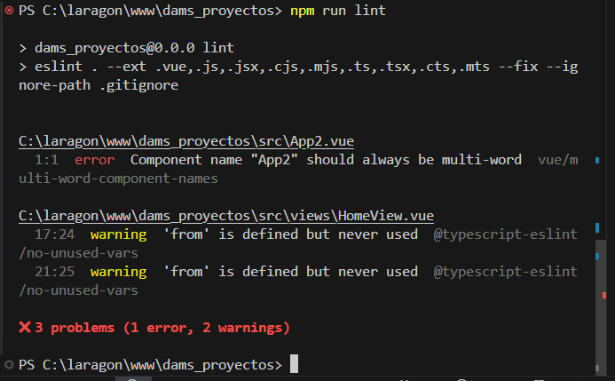

**Después de solucionado los errores:**

PS C:\laragon\www\dams_proyectos> **npm run lint**

> dams_proyectos@0.0.0 lint

> eslint . --ext .vue,.js,.jsx,.cjs,.mjs,.ts,.tsx,.cts,.mts --fix --ignore-path .gitignore

PS C:\laragon\www\dams_proyectos>

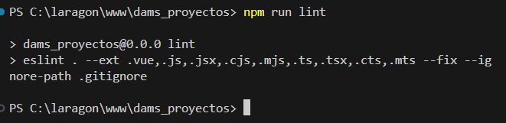

[**https://tablericons.com/**](https://tablericons.com/)

**Tabler Icons**

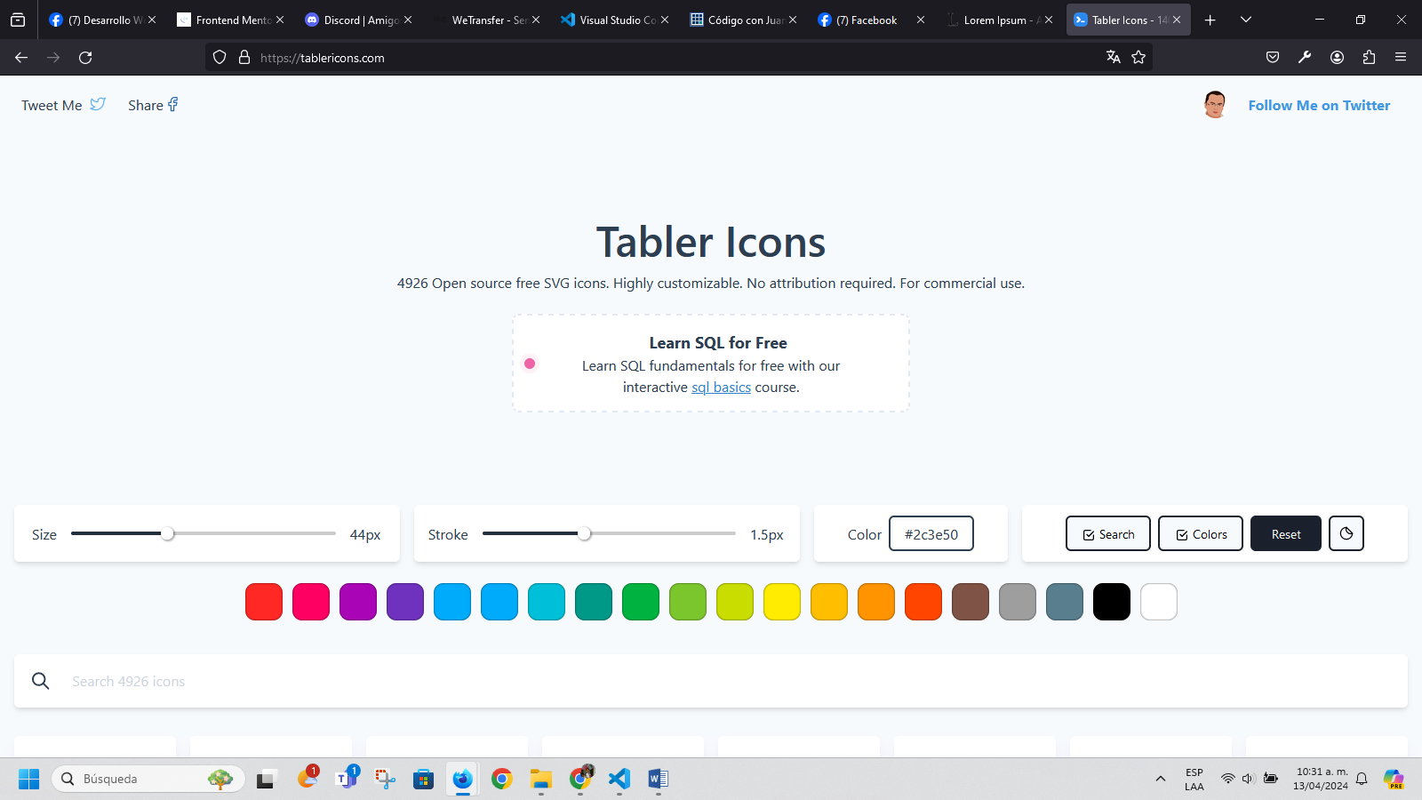

[**https://es.lipsum.com/**](https://es.lipsum.com/)

# Lorem Ipsum

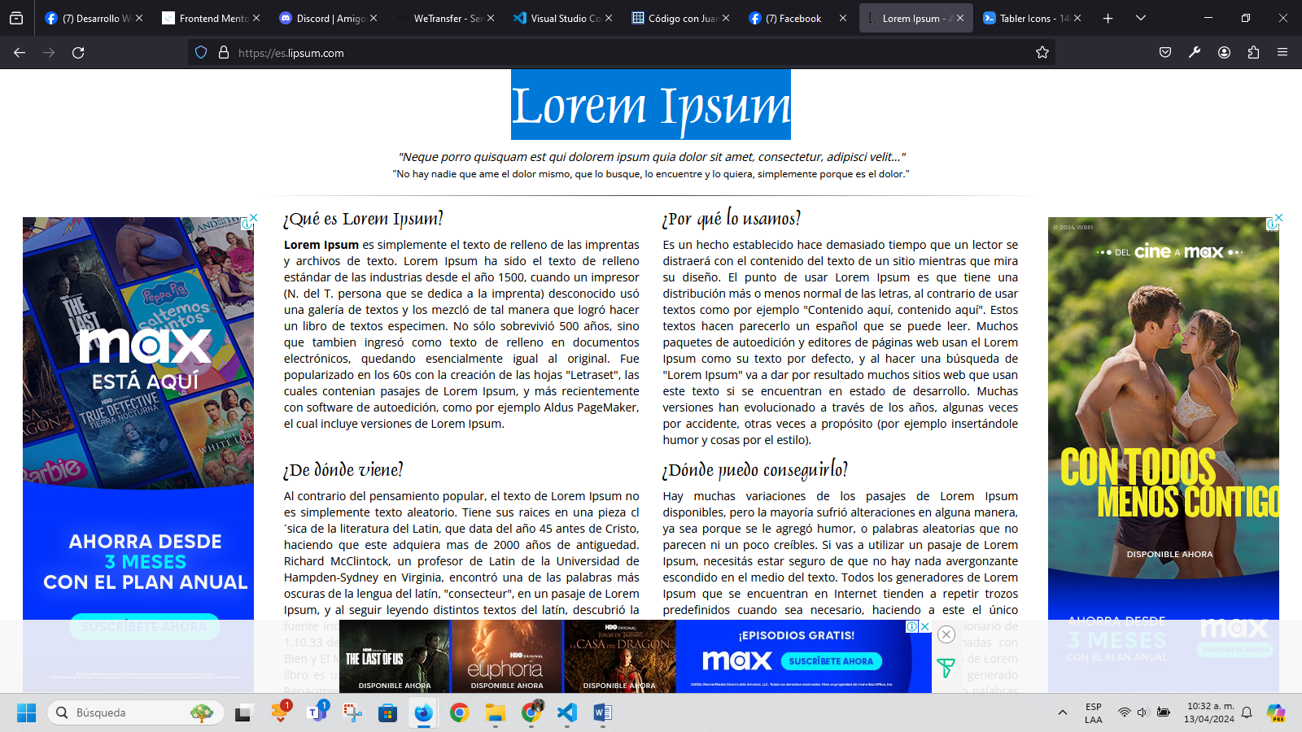

[**https://heroicons.dev/**](https://heroicons.dev/)

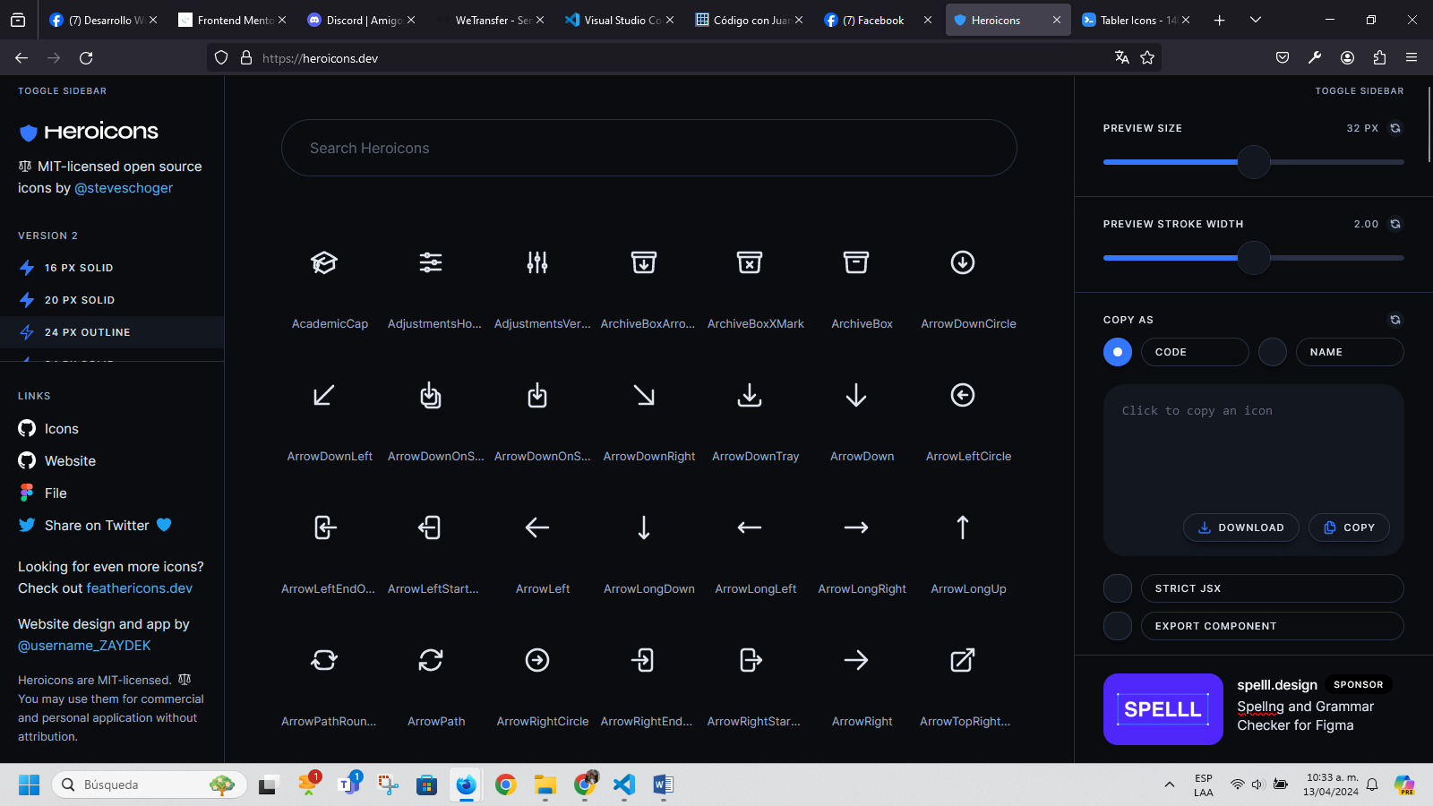

[**https://fontawesome.com/**](https://fontawesome.com/)

# Take the hassle out of icons in your website.

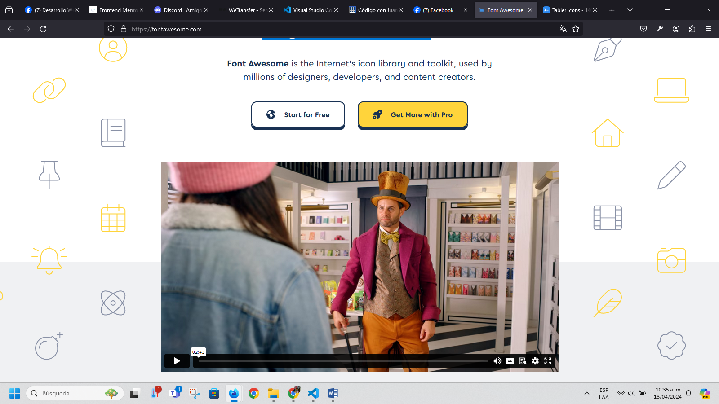

[**https://www.frontendmentor.io/**](https://www.frontendmentor.io/)

# Improve your coding skills by building realistic projects

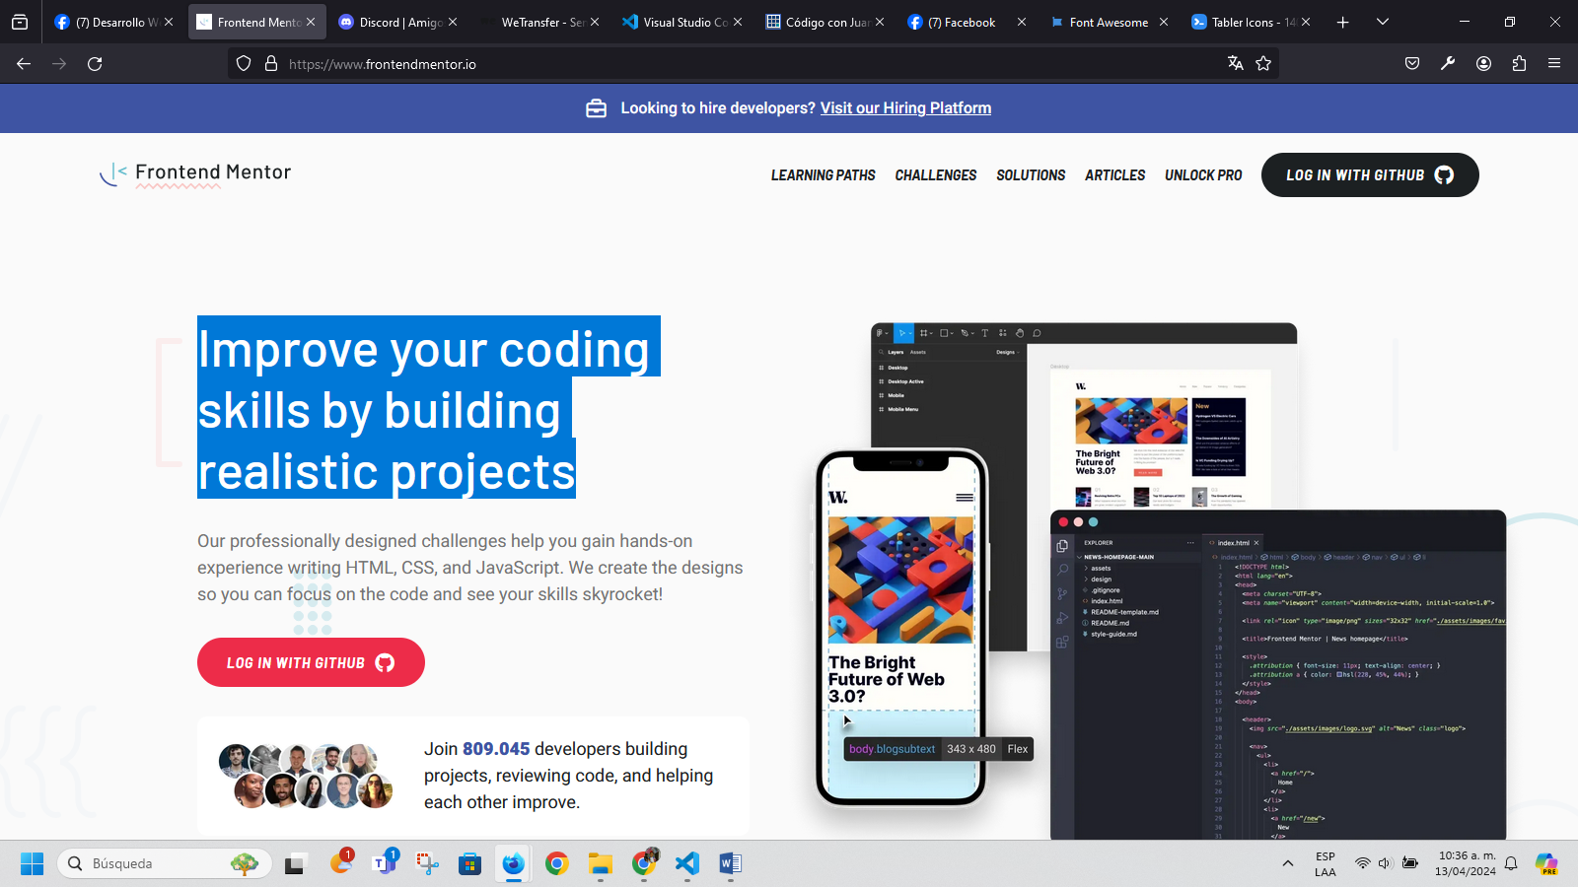

[**https://discord.com/channels/@me**](https://discord.com/channels/@me)

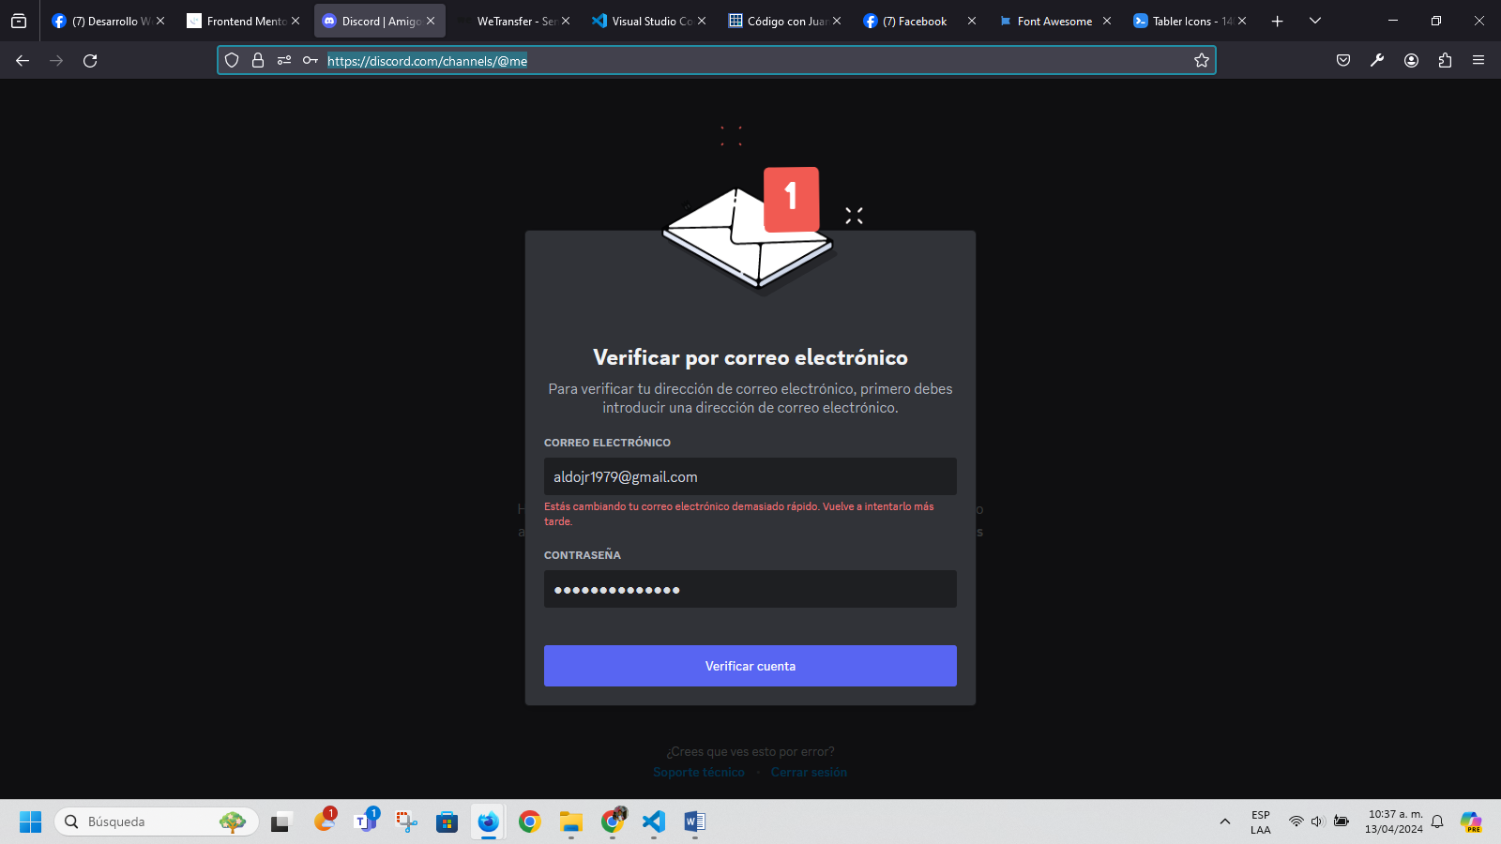

[**https://wetransfer.com/**](https://wetransfer.com/)

Transfiere ideas.**Cambia el mundo.**

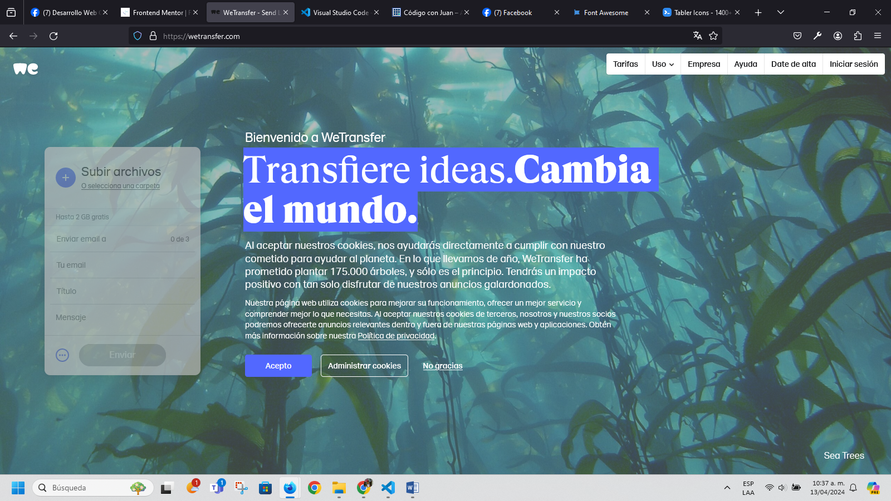

[**https://www.facebook.com/groups/1929227720680271/**](https://www.facebook.com/groups/1929227720680271/)

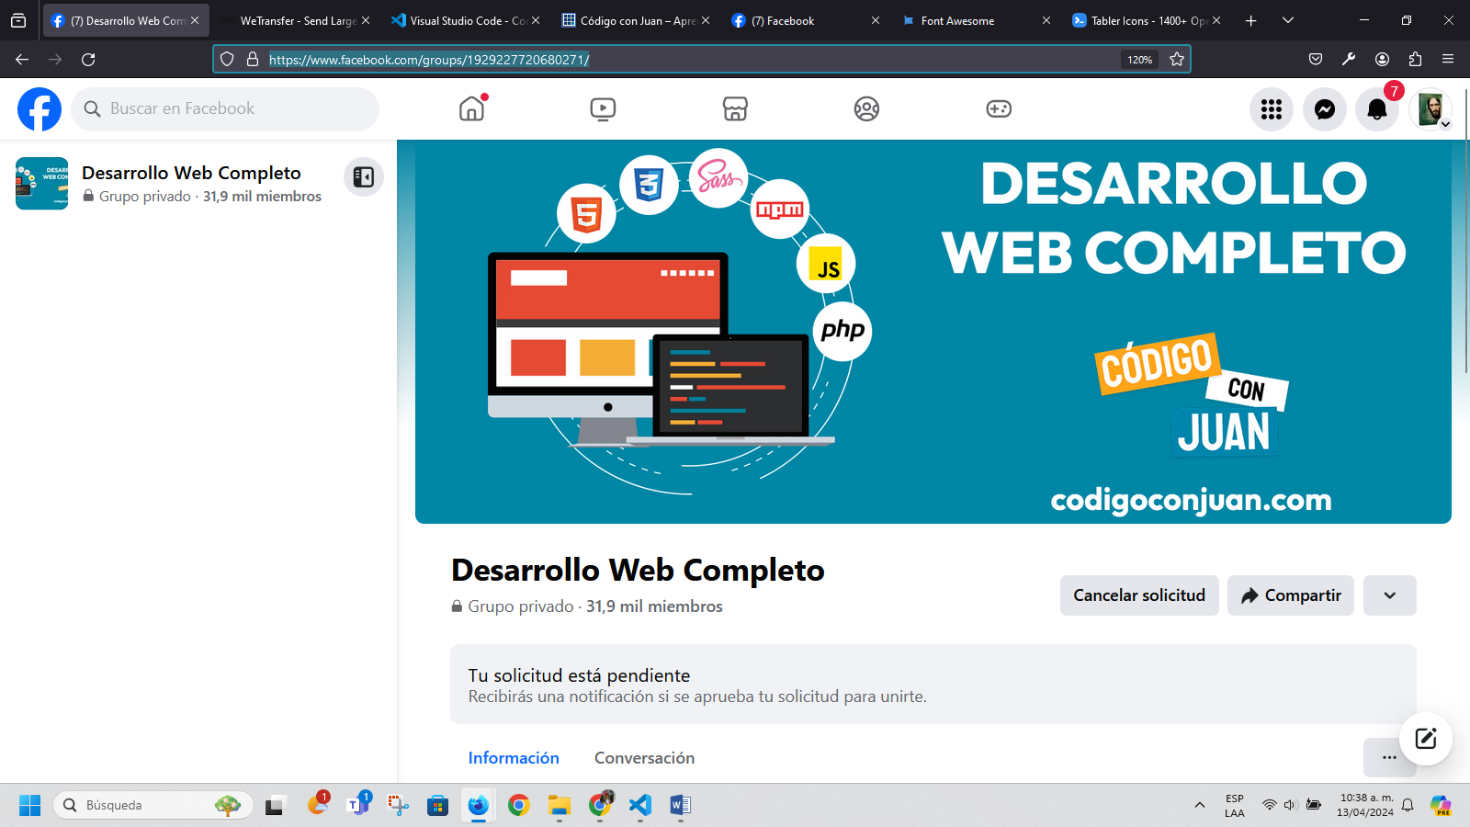

[**https://code.visualstudio.com/**](https://code.visualstudio.com/)

# Code editing. ****Redefined.****

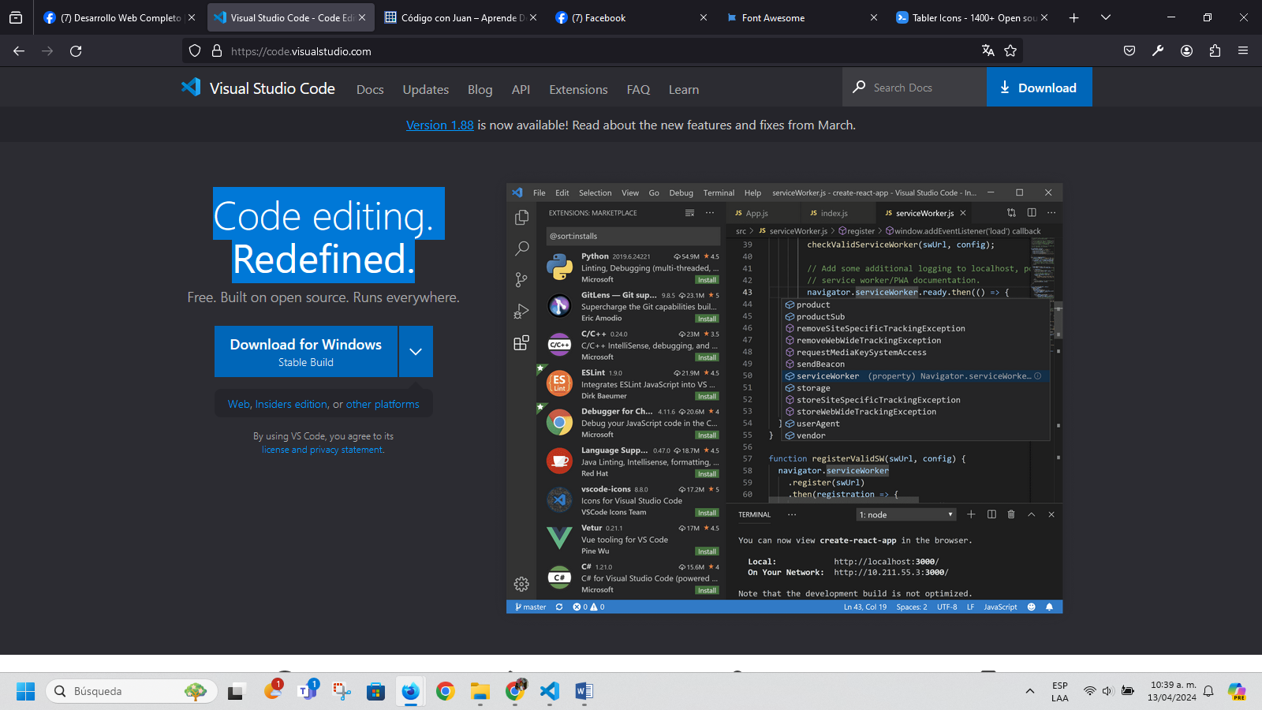

[**https://codigoconjuan.com/**](https://codigoconjuan.com/)

## AprendeDesarrollo Web

Aprende a crear páginas web para clientes u obtener un trabajo, conoce cada tecnología con cursos prácticos y paso a paso, los siguientes proyectos te enseñarán todo lo que debes saber de HTML, CSS, JS, PHP y MySQL

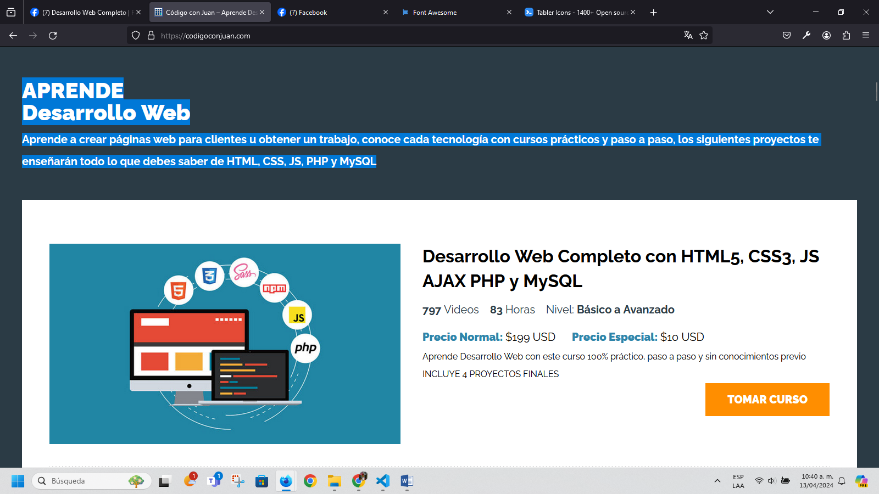

[**https://www.facebook.com/CodigoConJuanTuts**](https://www.facebook.com/CodigoConJuanTuts)



[**https://codigoconjuan.com/que-es-y-como-funciona-la-especificidad-en-css/**](https://codigoconjuan.com/que-es-y-como-funciona-la-especificidad-en-css/)

**QUÉ ES Y COMO FUNCIONA LA ESPECIFICIDAD EN CSS**



[**https://fonts.google.com/**](https://fonts.google.com/)

**Google FONTS**



[**http://necolas.github.io/normalize.css/**](http://necolas.github.io/normalize.css/)

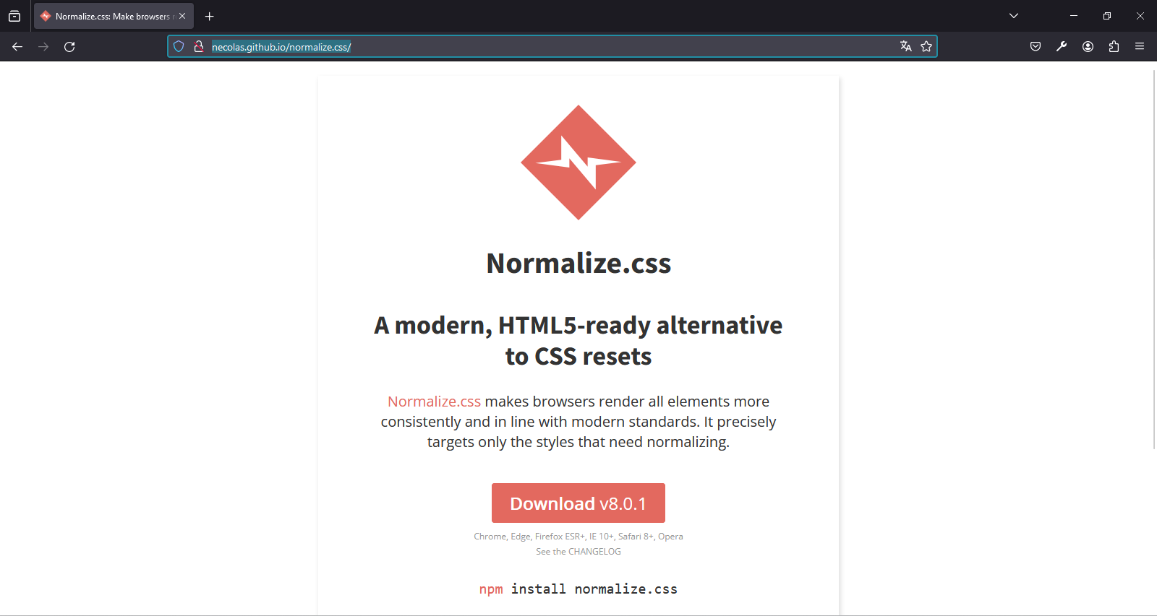

[**https://necolas.github.io/normalize.css/8.0.1/normalize.css**](https://necolas.github.io/normalize.css/8.0.1/normalize.css)

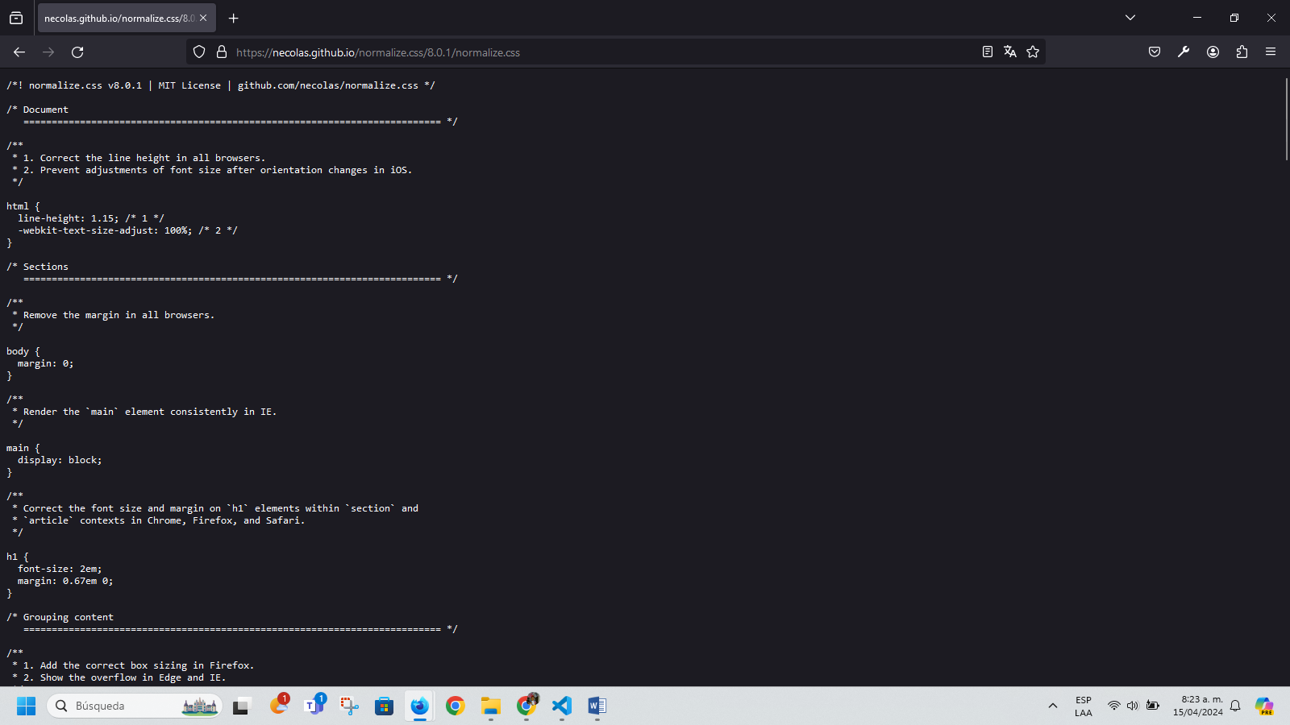

**Gastos**

**Cámaras de seguridad o IP**

**Fibras ópticas**

1. **Mirar empresas que hagan fibra óptica – cámaras de seguridad – eléctrica – paneles solares – Interenet saltelital – administración y configuración red LAN – Domotica – ampliación de zonas WIFI – radioenlace punto a punto y punto multipunto.**

**Estudio de campo – administración del tigre**

**Portafolio:**

**Redes WAN**

**Redes LAN**

**Ingeniero de Datos**

**Tema de proveedores.**

**Radios punto a punto Ubiquiti.**